

**FAMILY STUDIO**

**Chapter-1**

**Introduction and Object Project**

**INTRODUCTION**

This project is specially designed for Customers, because in this project customers Can Find online best parlour and features and also can registered as a User in this project **"Family** **studio”.**

Client can place their inquiry for any Particular question about this parlour **“FAMILY STUDIO”**

The **“Family studio”** project is a multi-user system.

It has been developed in a way that allows user to perform the function smoothly and with proper accuracy.

The system is developed in **HTML, CSS, PHP, My-SQL,** Java script for designing purpose.

So, this system is very useful for all types of client.

**Developed By: NANDANI SOLANKI**



**FAMILY STUDIO**

**HOW IT WORKS**

In this project first of all a homepage is displayed for all visitor, customers as well as registered customers.

This page will give information about family parlour details etc.

If user wants to place their inquiry, then they have to Login first. If the user is not a Registered User, He / She will have to click on the Signup Button and fill all fields in the registration form.

After registering in **“Family studio”** there you can see login button.

Users will have to login with registered **mobile number and password.**

After login, user will see User-Panel of **“Family studio”** Website.

There is various information about this parlour categories, inquiry and etc.

**Developed By: NANDANI SOLANKI**



**FAMILY STUDIO**

**Chapter-2**

**Tools Of Platform**

**REQUIREMENTS DETAILS**

**Developed By: NANDANI SOLANKI**

* SOFTWARE: -
* XAMPP Server Software
* Any Browser Like (Google Chrome, Internet Explorer, Mozilla etc.)
* HARDWARE: -
* Processor: P3 or higher
* RAM: 512 MB or higher
* Hard Disk: 50 GB or higher
* TOOLS USED: -
  + - Front End: HTML, CSS, JavaScript
    - Back End: PHP
    - Operating System: Windows 7 or higher



**FAMILY STUDIO**

**Chapter-3**

**System Analysis**

**3.1 Identification of needs**

**3.2 Preliminary investigation**

**3.3 Feasibility Study**

**3.4 Project Planning**

**3.5 Project Scheduling (PERT chart and Gantt chart)**

**3.6 Software Requirement Specification**

**3.7 Data Modeles**

**3.1 IDENTIFICATION OF NEEDS**

**Developed By: NANDANI SOLANKI**

The viewer of our system does not need to login as long as User wants to get Information only. But User wants to place Inquiry for **PARLOUR** with **FAMILY STUDIO** they must be registered to our website.



**FAMILY STUDIO**

User need to provides user name, e-mail, mobile number and password when creating an account.

**SDLC MODEL**

**Implementation**

**& Maintenance**

**Testing**

**Coding**

**Designing**

**Analysis**

**Planning**

**Developed By: NANDANI SOLANKI**



**FAMILY STUDIO**

**Developed By: NANDANI SOLANKI**

**SDLC STEPS**

* + - * **Requirement Gathering**
      * **Requirement Specification and Analysis**
      * **Design**
      * **Coding**
      * **Maintenance**

## **REQUIREMENT GATHERING: -**

In this phase of SDLC necessary information are collected. We collect the information in this phase through questionnaire and online websites also. We are also note down the requirements of the User.

**REQUIREMENT SPECIFICATION AND ANALYSIS:-**

The requirements are being specify in this phase. Analyst checks how the current system is working and then plans how to develop the proposed system and implement it.

## 



**FAMILY STUDIO**

## **DESIGN: -**

In this phase the design of both front-end and back-end is decided. In this phase we using HTML, CSS for designing, and designing of tables are also done properly in this phase.

## **CODING: -**

After the completion of designing there is a turn for coding. Coding is completed in various files. In most case coding takes the more time than the design.

## **TESTING: -**

In testing phase first unit level testing is done. In unit level testing the software is tested in an individual file. After the unit testing of each file the integration testing done. In integration testing the files are tested into their own package. At last, in the system testing the whole system is run on the INTERNET ENVIRONMENT.

## **MAINTENANCE: -**

The proper maintenance is given as indicate in the SRS (Software Requirement Specification). It is a responsibility of Developer to maintain the software during its criteria mentioned in SRS document.

**Developed By: NANDANI SOLANKI**



**FAMILY STUDIO**

**Developed By: NANDANI SOLANKI**

* 1. **PRILIMINARY INVESTIGATION**

## **OUR OBJECTIVES: -**

* Admin can add new, Delete and Edit records.
* User can browse category wise.
* User can handle all type of information easily
* User can search through search bar.
* Easy updating, time saving, quick process.
* User can update their registration details.
* User can get guidance of colleges and courses through different steps.



**FAMILY STUDIO**

## **PLATFORM SPECIFICATION: -**

* We have used windows based developing graphical based applications our software will provide support GUI efficiently. It must for our system because for our project.
* It is very useful and support of PHP and Java Script control and component.
* Use of Table for menu create and display Form in it.
* It is easy to integrity database report use with Data Report.
* PHP platform is mostly use for development Web Based Application
* Regular version of operating system use with it.
* Always need to back end tool for developed web Application with front tool.
* Starting a new business all of the organization have some requirement for it.
* There are many reasons for starting a new business or modify the old system.
* Business require set is depending on top level organization that is manager, administrator etc.

**Developed By: NANDANI SOLANKI**



**FAMILY STUDIO**

* 1. **FEASIBILITY STUDY**
* A feasibility analysis usually involves a thorough assessment of the operational (need), financial and technical aspects of a proposal.
* Feasibility study is the test of the system proposal made to identify whether the user needs may be satisfied using the current software and hardware technologies, whether the system will be cost effective from a business point of view and whether it can be developed with the given budgetary constraints.
* A feasibility study should be relatively cheap and done at the earliest possible time.
* Depending on the study, the decision is made whether to go ahead with a more detailed analysis.
* When a new project is proposed, it normally goes through feasibility assessment.
* Feasibility study is carried out to determine whether the proposed system is possible to develop with available resources and what should be the cost consideration.
* Facts considered in the feasibility analysis were.

**Developed By: NANDANI SOLANKI**



**FAMILY STUDIO**

## **1) TECHNICAL FEASIBILITY: -**



**FAMILY STUDIO**

* Technical feasibility is considered. In terms of technical requirements and their availability in the market. It determines whether the current level of technology supports the proposed system or not. The technical possibility of proposed system is as follows.
* The unit does possess the hardware as well as related software for the project.
* The proposed system does not require much technical detail.
* It just requires window operating system.
* The organization has already purchased all the enough devices for latest technical.
* These technical specifications are easily available in the market.
* Hence, the proposed system is technically feasible.

**Developed By: NANDANI SOLANKI**



**FAMILY STUDIO**

## **2) ECONOMICAL FEASIBILITY STUDY: -**

* Economic justification is generally the "Bottom Line" consideration for most systems.
* Economic justification includes a broad range of concerns that includes cost benefit analysis.
* In this we weight the cost and the benefits associated with the candidate system and if it suits the basic purpose of the organization i.e. profit making, the project is making to the analysis and design phase.
* The financial and the economic questions during the preliminary investigation are.
  + - ***Verified to Estimate the Following:***
* The cost to conduct a full system investigation.
* The cost of hardware and software for the class of application being considered.
* The benefits in the form of reduced cost.
* The proposed system will give the minute information; as a result, the performance is improved which in turn may be expected to provide increased profits.
* This feasibility checks whether the system can be developed with the available funds. This can be done economically if planned judicially, so it is economically feasible. The cost of project depends upon the number of man hours required.



**FAMILY STUDIO**

**Developed By: NANDANI SOLANKI**

## **3) OPERATIONAL FEASIBILITY STUDY: -**

* It is mainly related to human organizations and political aspects. The points to be considered are:
* What changes will be brought with the system?
* What organization structures are disturbed?
* What new skills will be required?
* Do the existing staff members have these skills? If not, can they be trained in due course of time?
* The system is operationally feasible as it very easy for the End users to operate it. It only needs basic information about Windows platform.



**FAMILY STUDIO**

* 1. **PROJECT PLANNING**

|  |  |  |  |  |
| --- | --- | --- | --- | --- |
| **No.** | **Task Name** | **Start** | **Finish** | **Duration** |
| **1.**  **2.**  **3.**  **4.**  **5.**  **6.** | **Planning**  **Analysis**  **Designing**  **Coding**  **Implementation**  **Testing**  **TOTAL** | **02 -June**  **10-June**  **03 -July**  **27 -July**  **17-Aug**  **30-Aug** | **08 -June**  **01-July**  **24-July**  **12-Aug**  **28-Aug**  **5-Sep** | **1 Week**  **3.1 Week**  **3.1 Week**  **2.2 Week**  **1.5Week**  **1 Week**  **86 DAYS** |



**FAMILY STUDIO**

**Developed By: NANDANI SOLANKI**

* 1. **PROJECT SCHEDULING**

**PERT CHART :** This chart represents the development of our system Date wise.

**Code Data Base Part-27-July to 12- Aug**

**Designing Base Part-3- 24July**

**Documentation 3-SEP TO 5-SEP**

**Finish**

**Integrated Testing 30-Aug to 5-Sep**

**Requirement specification 2-June to 8-June**

**PERT CHART**

**Code GUI Part 15-Aug to 2-Sep**

**Designing GUI Part 1-Aug to 10-Ayg**

**GANTT CHART :** This is a graphical representation of the date wise development of our project system. It is very similar to the PERT chart except that it is represented graphically.

## **ID** **TASK NAME JUN 19 JUL 19 AUG 19 SEP 19**

1. **Planning**

**02 JUN - 08 JUN**

1. **Analysis**

**10 JUL - 01 JUL**

1. **Designing**

**27 AUG -12 AUG**

**03 JUL – 24 JUL**

1. **Coding**

**17 AUG -28 AUG**

1. **Implementation**

**30 Aug – 5SEP**

1. **Testing**

**Developed By: NANDANI SOLANKI**



**FAMILY STUDIO**

**3.6 SOFTWARE REQUIREMENT**

## **PHP:**

* PHP is a widely-used general-purpose scripting language that is especially suited for Web development and can be embedded into HTML.
* PHP generally runs on a web server, taking PHP code as its input and creating Web pages as output.
* However, it can also be used for command-line scripting and client-side GUI applications.
* PHP can be deployed on most web servers and on almost every operating system and platform free of charge.
* The PHP Group also provides the complete source code for users to build, customize and extend for their own use.

**Developed By: NANDANI SOLANKI**



**FAMILY STUDIO**

* PHP primarily acts as a filter. The PHP program takes input from a file or stream containing text and special PHP instructions and outputs another stream of data for display.
* From PHP 4, the PHP parser compiles input to produce byte code for processing by the Send Engine, giving improved performance over its interpreter predecessor. PHP 5 uses the Send Engine II.
* Originally designed to create dynamic web pages, PHP's principal focus is server-side scripting.

**Developed By: NANDANI SOLANKI**



**FAMILY STUDIO**

### **My SQL:**

* ***MY SQL is a database management system.***
* A database is a structured collection of data. It may be anything from a simple shopping list to a picture gallery or the vast amounts of information in a corporate network. To add, access, and process data stored in a computer database, you need a database management system such as MySQL Server. Since computers are very good at handling large amounts of data, database management systems play a central role in computing, as standalone utilities, or as parts of other applications.
* ***MY SQL databases are relational.***
* A relational database stores data in separate tables rather than putting all the data in one big storeroom. The database structures are organized into physical files optimized for speed. The logical model, with objects such as databases, tables, views, rows, and columns, offers a flexible programming environment. You set up rules governing the relationships between different data fields, such as one-to-one, one-to-many, unique, required or optional, and "pointers" between different tables. The database enforces these rules, so that with a well-designed database, your application never sees inconsistent, duplicate, orphan, out-of-date, or missing data.

**Developed By: NANDANI SOLANKI**



**FAMILY STUDIO**

* The SQL part of "MySQL" stands for "Structured Query Language". SQL is the most common standardized language used to access databases. Depending on your programming environment, you might enter SQL directly (for example, to generate reports), embed SQL statements into code written in another language, or use a language-specific API that hides the SQL syntax.
* SQL is defined by the ANSI/ISO SQL Standard. The SQL standard has been evolving since 1986 and several versions exist.
* ***MySQL software is Open Source.***
* Open Source means that it is possible for anyone to use and modify the software. Anybody can download the MySQL software from the Internet and use it without paying anything. If you wish, you may study the source code and change it to suit your needs. The MySQL software uses the GPL (GNU General Public License), http://www.fsf.org/licenses/, to define what you may and may not do with the software in different situations. If you feel uncomfortable with the GPL or need to embed MySQL code into a commercial application, you can buy a commercially licensed version from us.

**Developed By: NANDANI SOLANKI**



**FAMILY STUDIO**

**Developed By: NANDANI SOLANKI**

* ***The MySQL Database Server is very fast, reliable, scalable, and easy to use.***
* ***MySQL Server works* in client/server or embedded systems**



**FAMILY STUDIO**

**JAVA Script:**

* ***JAVA SCRIPT ORIGINS: -***
* JavaScript was released by Netscape and Sun Microsystems in 1995.
* However, JavaScript is not the same thing as Java. o It is a programming language.
* It is an interpreted language.
* It is object based programming.
* It is widely used and supported
* It is accessible to the beginner.
* ***USES OF JA VA SCRIPT: -***
* Use it to add multimedia elements with JavaScript you can show, hide, change, resize images, and create image rollovers. You can create scrolling text across the status bar.
* Create pages dynamically Based on the user's choices, the date, or other external data, JavaScript can produce pages that are customized to the user.

**Developed By: NANDANI SOLANKI**



**FAMILY STUDIO**

## **HTML:**

* HTML is the standard Mark-up language for creating web pages and CSS and JavaScript it forms a triad of cornerstone technologies for the WWW.
* Web browsers receive HTML documents from a web server or from local storage and render them into multimedia web pages.
* HTML describes the structure of a web page semantically and originally included cues for the appearance of the document.
* **Hyper Text Mark-up Language (HTML)** can embed programs written in a scripting language such as JavaScript which affect the behavior and content of web pages.
* Inclusion of CSS defines the look and layout of content. The World Wide Web consortium (W3C), maintainer of both the HTML and the CSS standards, has encouraged the use of CSS over explicit presentational HTML since 1997.

**Developed By: NANDANI SOLANKI**



**FAMILY STUDIO**

**Developed By: NANDANI SOLANKI**

**CSS :**

* Cascading Style Sheet (CSS) is a Style sheet language used for describing the presentation of a document written in a Mark-up language. Although most often used to set the visual style of web pages and user interfaces written in HTML and XHTML, the language can be applied to any XML document, including plain XML, SVG and XUL, and is applicable to rendering in speech, or on other media. Along with HTML and JavaScript, CSS is a cornerstone technology used by most websites to create visually engaging web pages, user interfaces for web applications, and user interfaces for many mobile applications.
* CSS is designed primarily to enable the separation of presentation and content, including aspects such as the layout, colors, and fonts.



**FAMILY STUDIO**

**3.7 DATA MODEL**



**FAMILY STUDIO**

* **Data Flow Diagram: -**

1. **Visitor Data Flow Diagram:**

**Home**

**Features**

**Services**

**Testmonial**

**feedback**

**Contact Us**

**About Us**

**Feedback**

**contactus**

**registration**

**Login**

**Sign Up**

**Developed By: NANDANI SOLANKI**



**FAMILY STUDIO**

**2) User Data Flow Diagram:**

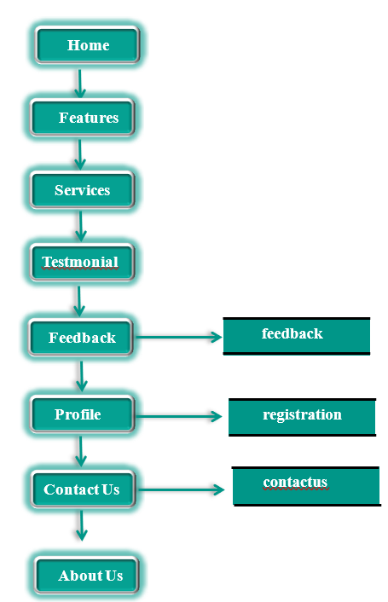

**Home**

**Testmonial**

**Services**

**Features**

**feedback**

**Contact Us**

**Profile**

**Feedback**

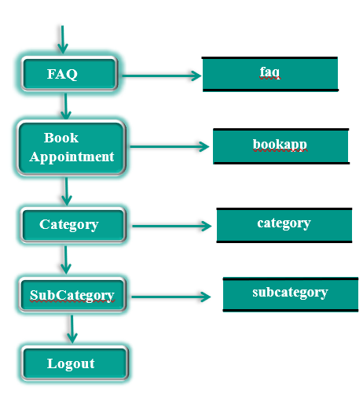

**registration**

**About Us**

**contactus**

**Developed By: NANDANI SOLANKI**



**FAMILY STUDIO**

**Developed By: NANDANI SOLANKI**



**FAMILY STUDIO**

**3)** **Admin Data Flow Diagram:**

**Home**

**Booking**

**Category**

**category**

**subcategory**

**Subcategory**

**bokkapp**

**feedback**

**FAQ**

**Client**

**Feedback**

**registration**

**faq**

**Logout**

**Developed By: NANDANI SOLANKI**

* **Data Flow Diagram:**

**1) Visitor Data Flow Diagram:**

**Services**

**About Us**

**Contact Us**

**Feedback**

**Sign Up**

**Home**

**contactus**

**registration**

**feedback**

**Testmonial**

**Features**

**User**

**2) User Data Flow Diagram:**

**Testmonial**

**Feature**

**About Us**

**Sign Up**

**Contact Us**

**Feedback**

**Services**

**Home**

**Developed By: NANDANI SOLANKI**

**Developed By: NANDANI SOLANKI**

**registration**

**contactus**

**feedback**

**NO**

**YES**

**Logout**

**SubCategory**

**Category**

**FAQ**

**Book Appointment**

**Contact Us**

**Profile**

**Feedback**

**Feature**

**Home**

**subcategory**

**category**

**faq**

**bookapp**

**contactus**

**registration**

**feedback**

**3) Admin** **Data Flow Diagram:-**

**Testmonial**

**Feature**

**About Us**

**Sign Up**

**Contact Us**

**Feedback**

**Services**

**Home**

**Developed By: NANDANI SOLANKI**

**Developed By: NANDANI SOLANKI**

**registration**

**contactus**

**feedback**

**NO**

**YES**

**FAQ**

**Booking**

**Client**

**Feedback**

**Logout**

**SubCategory**

**Category**

**Home**

**subcategory**

**category**

**registration**

**faq**

**bookapp**

**feedback**

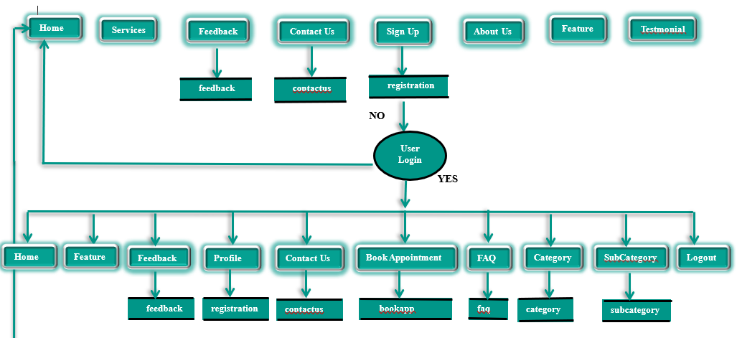



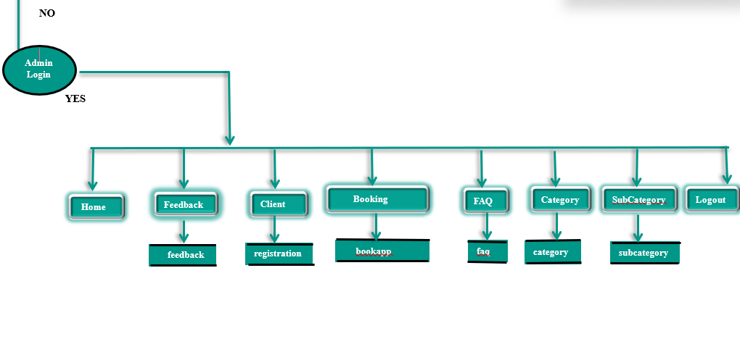

**Developed By: NANDANI SOLANKI**



**FAMILY STUDIO**

* **ER Diagrams :**

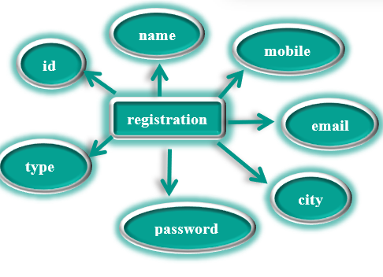

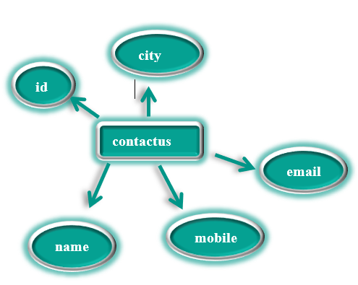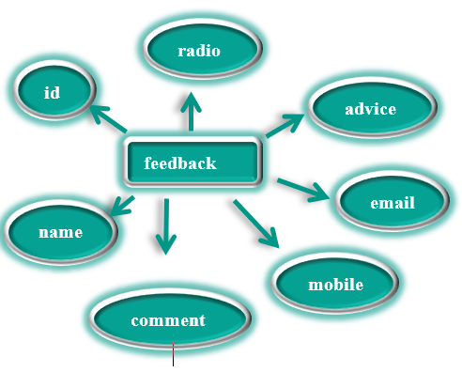

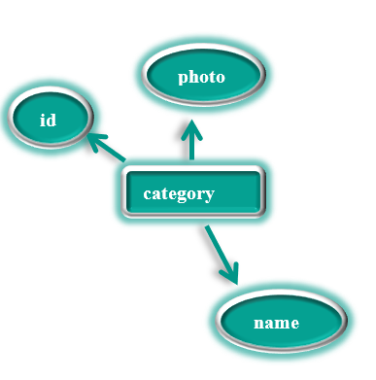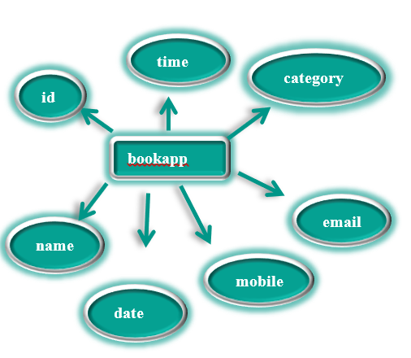

**Developed By: NANDANI SOLANKI**



**FAMILY STUDIO**

* **User Case Diagram:**

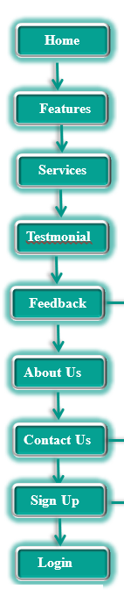



**Visitor**

**Developed By: NANDANI SOLANKI**

**User**

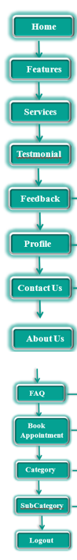





**FAMILY STUDIO**

* **User Case Diagram:**

**Developed By: NANDANI SOLANKI**



**FAMILY STUDIO**

* **User Case Diagram:**

**Developed By: NANDANI SOLANKI**

**Admin**

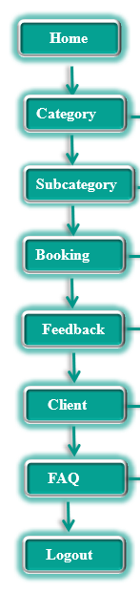





**FAMILY STUDIO**

**3.8 NORMALIZATION**

* Normalization rules are divided into following normal form.

1. **First Normal Form**
2. **Second Normal Form**
3. **Third Normal Form**
4. **First Normal Form (INF): -** As per First Normal Form, no two Rows of data must contain repeating group of information id each set of columns must have a unique value, such that multiple columns cannot be used to fetch the same row. Each table should be organized into rows, and each row should have a primary key that distinguishes it as unique. The Primary key is usually a single column, but sometimes more than one column can be combined to create a single primary key. For example, consider a table which is not in First normal form.
5. **Second Normal Form (2NF): -** As per the Second Normal Form there must not be any partial dependency of any column on primary key. It means that for a table that has concatenated primary key, each column in the table that is not part of the primary key must depend upon the entire concatenated key for its existence.

**Developed By: NANDANI SOLANKI**



**FAMILY STUDIO**

If any column depends only on one part of the concatenated key, then the table fails Second normal form.

In User Table the candidate key will be column. Now, both the above tables qualify for Second Normal Form and will never suffer from Update Anomalies. Although there are a few complex cases in which table in Second Normal Form suffers Update Anomalies, and to handle those scenarios Third Normal Form is there.

1. **Third Normal Form (3NF): -** Third Normal form applies that every nonprime attribute of table must be dependent on primary key, or we can say that, there should not be the case that a non-prime attribute is determined by another non-prime attribute. So, this transitive functional dependency should be removed from the table and also the table must be in Second Normal form. For example, consider a table with following fields.

In this table User id is Primary key, but street, city and state depend upon Zip. The dependency between zip and other fields is called transitive dependency. Hence to apply 3NF, we need to move the street, city and state to new table, with Zip as primary key.

**The advantage of removing transitive dependency is,**

 Amount of data duplication is reduced.

 Data integrity achieved.

**Developed By: NANDANI SOLANKI**



**FAMILY STUDIO**

**Developed By: NANDANI SOLANKI**

**Chapter-4**

**System Design**

**4.1 Tables**

**4.2 Database Structure**

**4.3 User Interface**

**4.1 TABLES**

* **Visitor Table:**

**1) Registration (name, email, mobile, password, city, type ):**

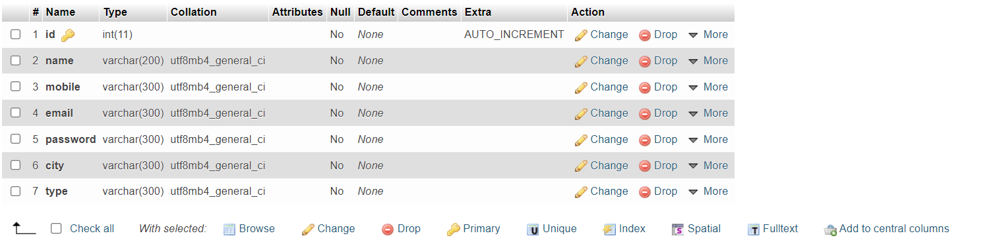

**2) Feedback:**





**FAMILY STUDIO**

**3) Contact Us:**

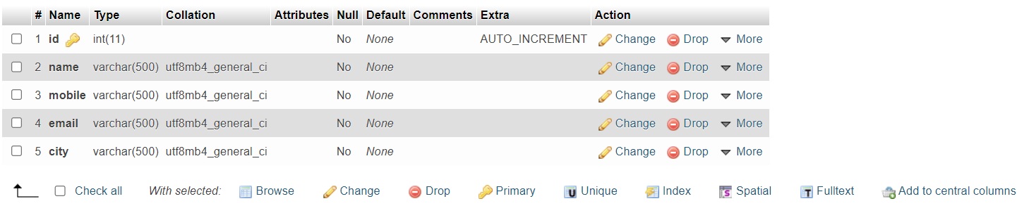



**FAMILY STUDIO**

**Developed By: NANDANI SOLANKI**



**FAMILY STUDIO**

* **User Table:**

**1) Feedback:**





**FAMILY STUDIO**

**Developed By: NANDANI SOLANKI**

**2) Contact Us:**





**FAMILY STUDIO**



**FAMILY STUDIO**

**3) Book Appointment:**

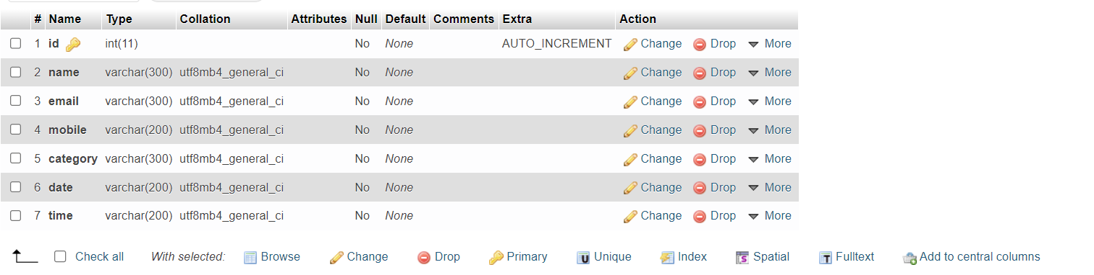



**FAMILY STUDIO**

**4) Profile:(registration)**

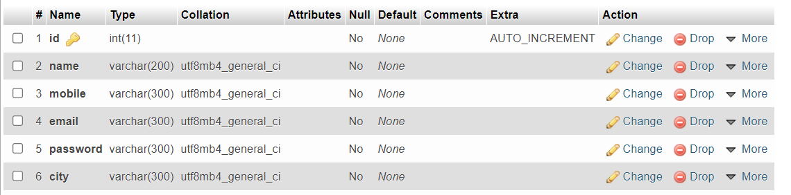



**FAMILY STUDIO**

**5) FAQ(Frequently Asked Question):**

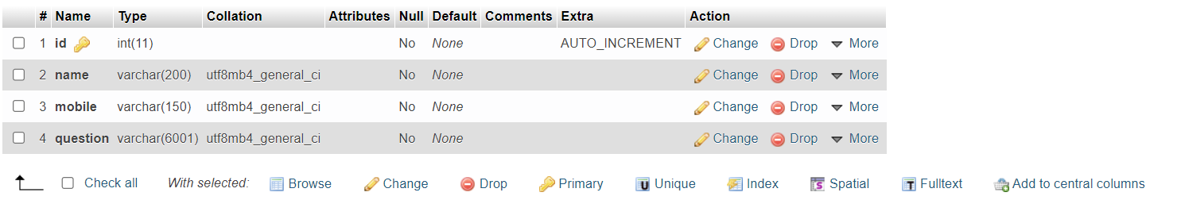



**FAMILY STUDIO**

**Developed By: NANDANI SOLANKI**



**FAMILY STUDIO**

* **Admin Table:**

**1) Category:**

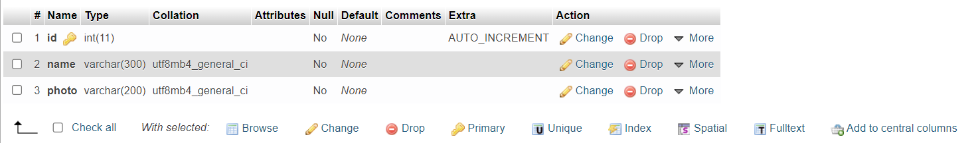

**2)Subcategory:**

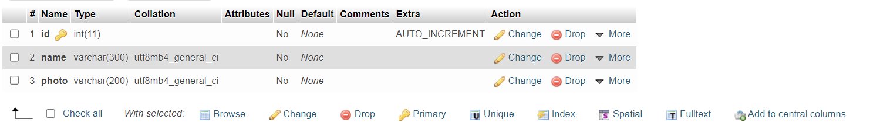

**3) Booking:**



**Developed By: NANDANI SOLANKI**

**4) Client:(registration)**





**FAMILY STUDIO**

**5) FAQ(Frequently Asked Question):**





**FAMILY STUDIO**

**Developed By: NANDANI SOLANKI**



**FAMILY STUDIO**

**4.2 DATABASE STRUCTURE**

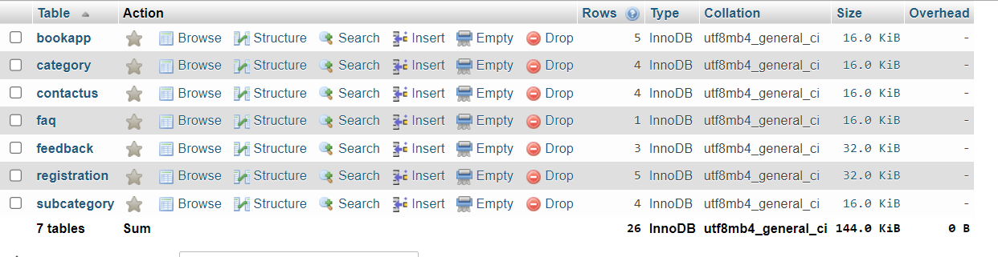

**Developed By: NANDANI SOLANKI**



**FAMILY STUDIO**

**Developed By: NANDANI SOLANKI**

**4.3 USER INTERFACE**

**1)Visitor Side Screenshot:**



**FAMILY STUDIO**

* **Index page:**

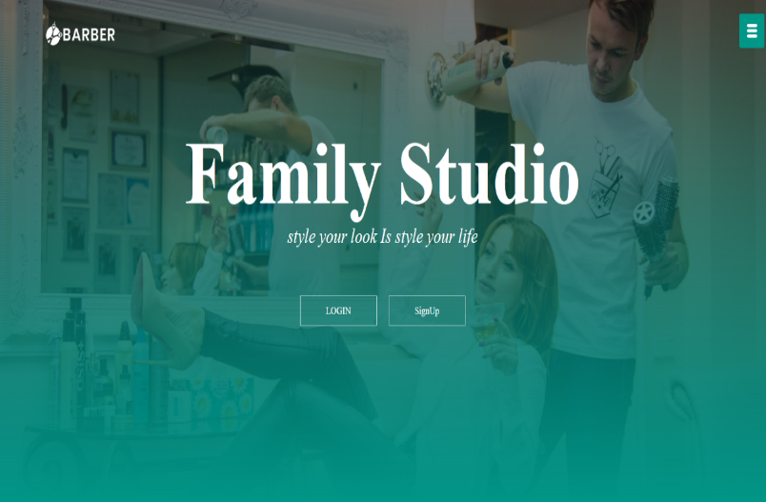

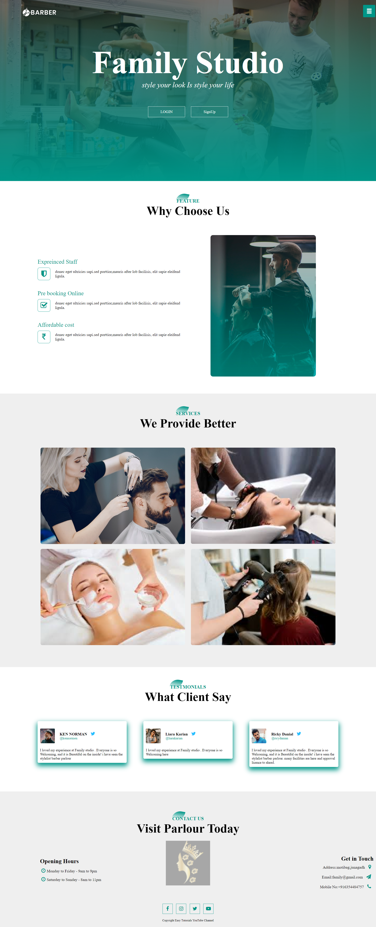

* **Feature :**

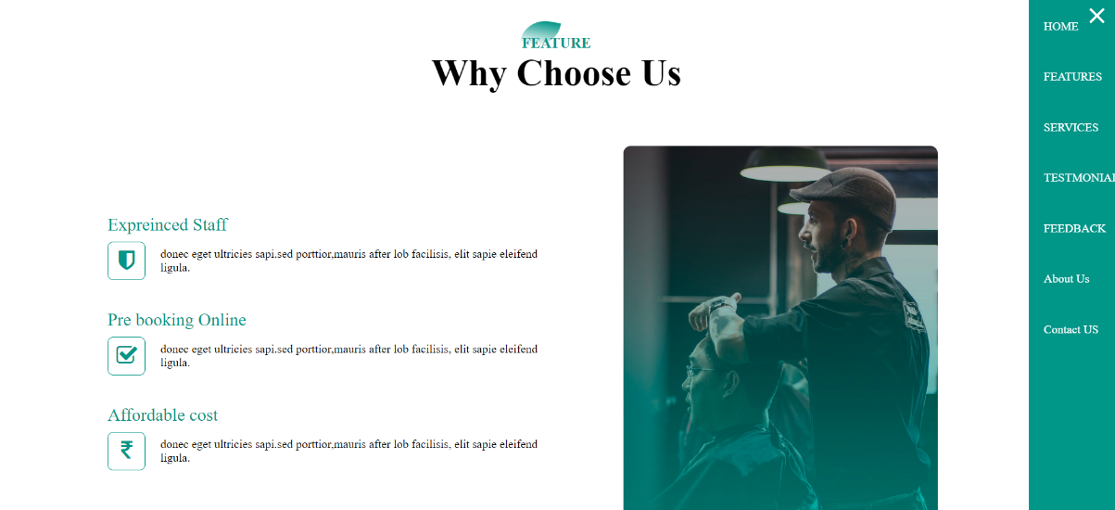

**Developed By: NANDANI SOLANKI**



**FAMILY STUDIO**

* **Services:**



**FAMILY STUDIO**

* **Testmonials:**

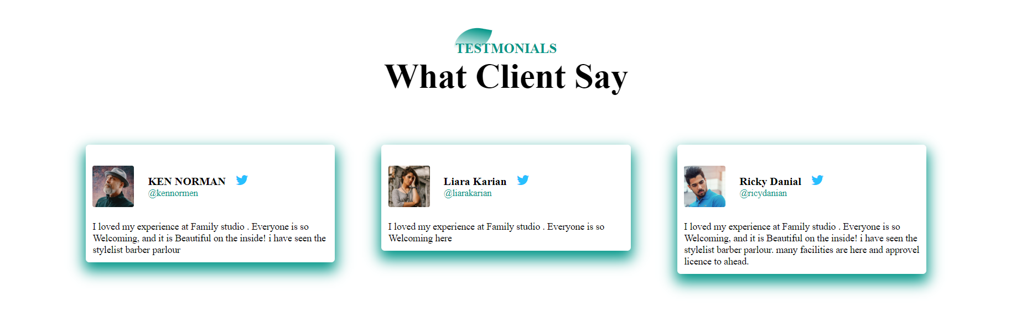

* **Parlour Contactus:**

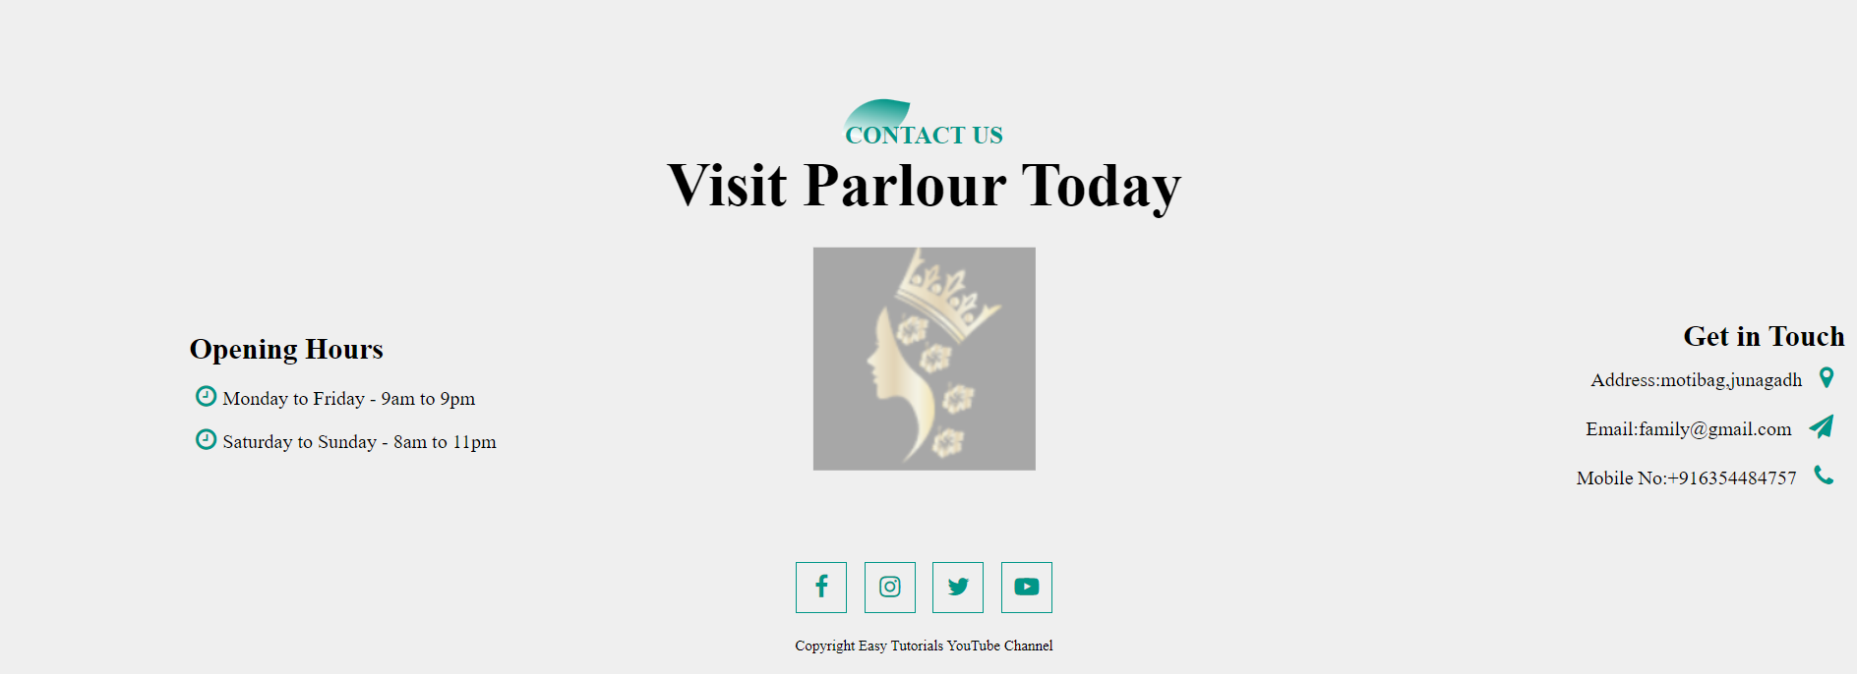

**Developed By: NANDANI SOLANKI**

**Developed By: NANDANI SOLANKI**

* **Feedback page:**



**FAMILY STUDIO**

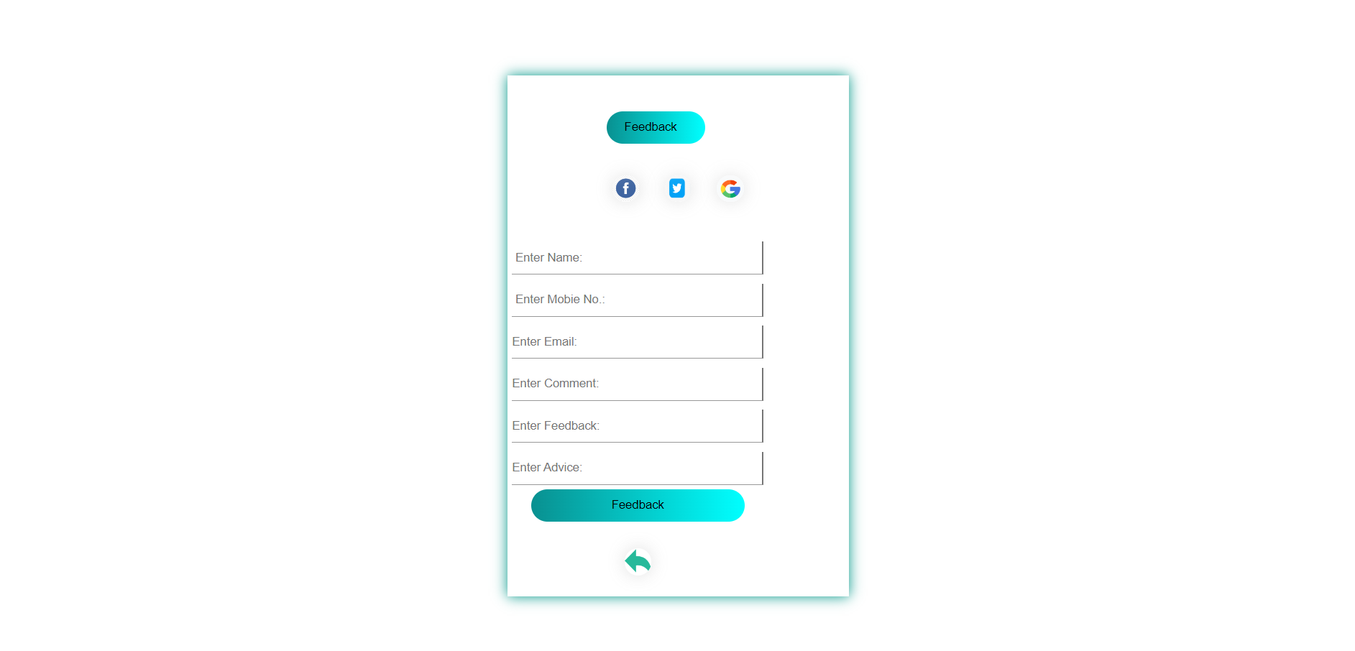

* **Contact us:**

**Developed By: NANDANI SOLANKI**

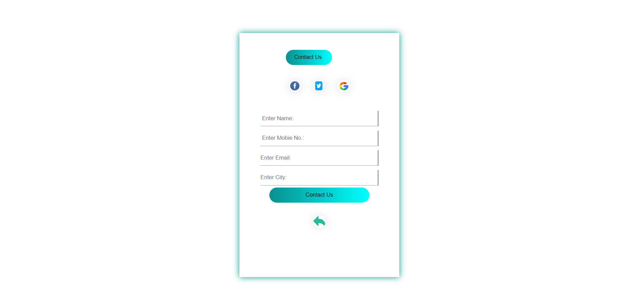



**FAMILY STUDIO**

* **Login page:**

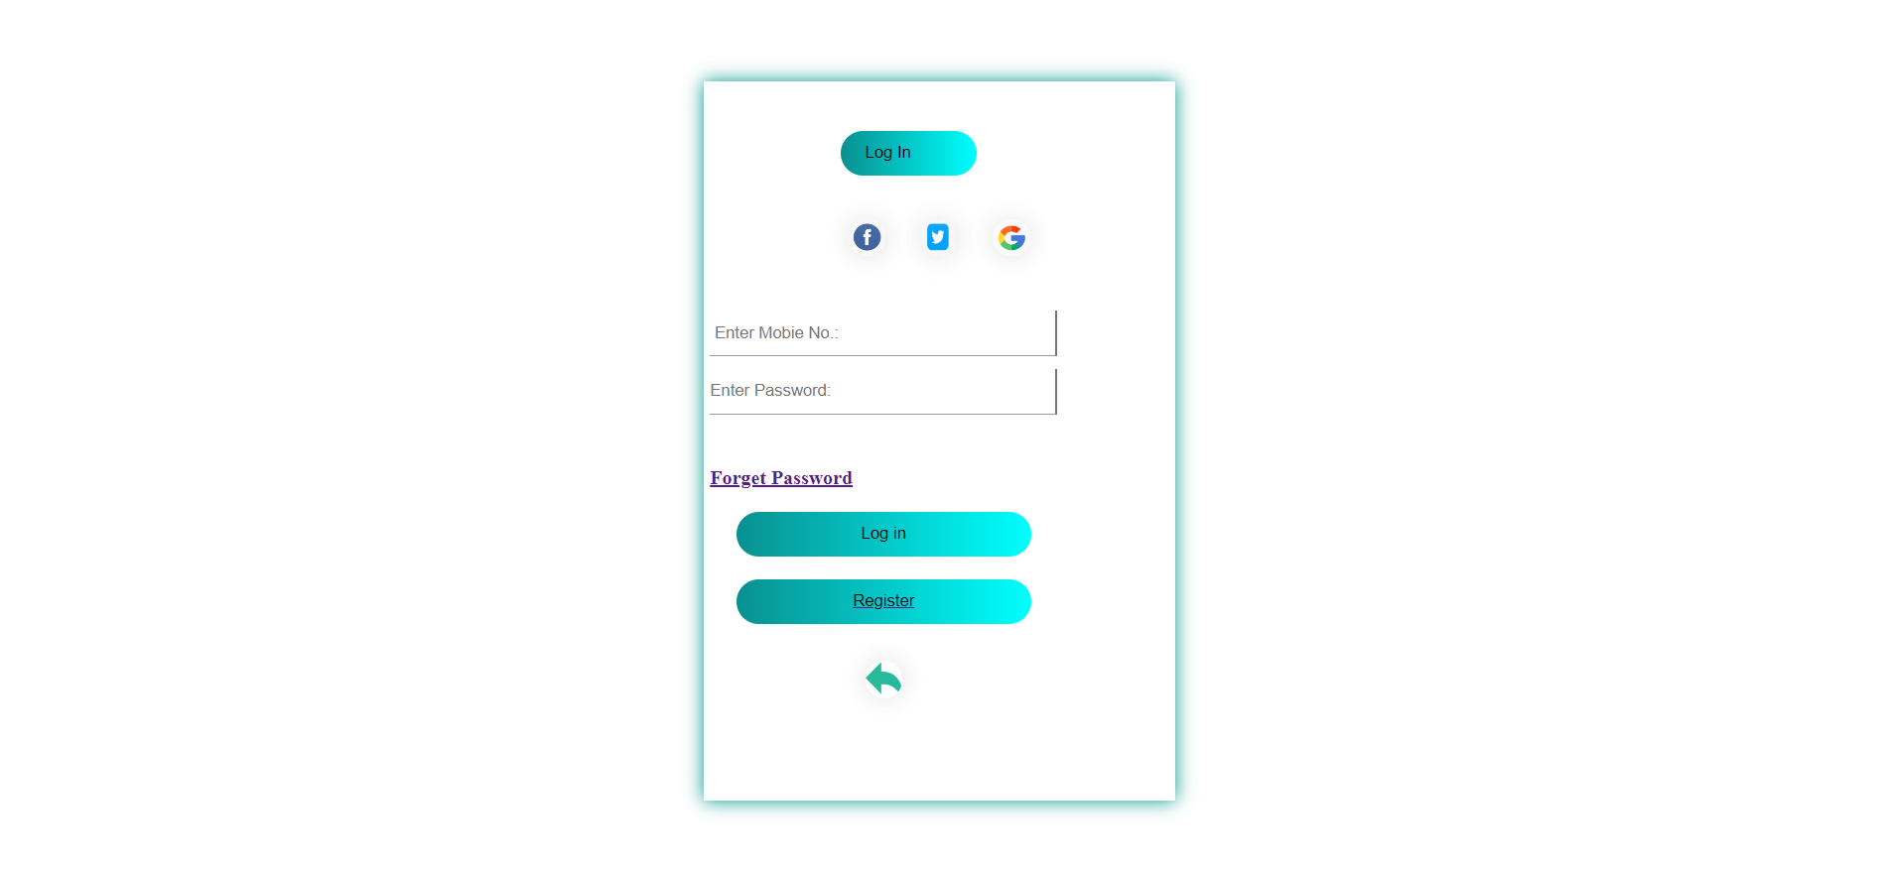



* **Register page:**

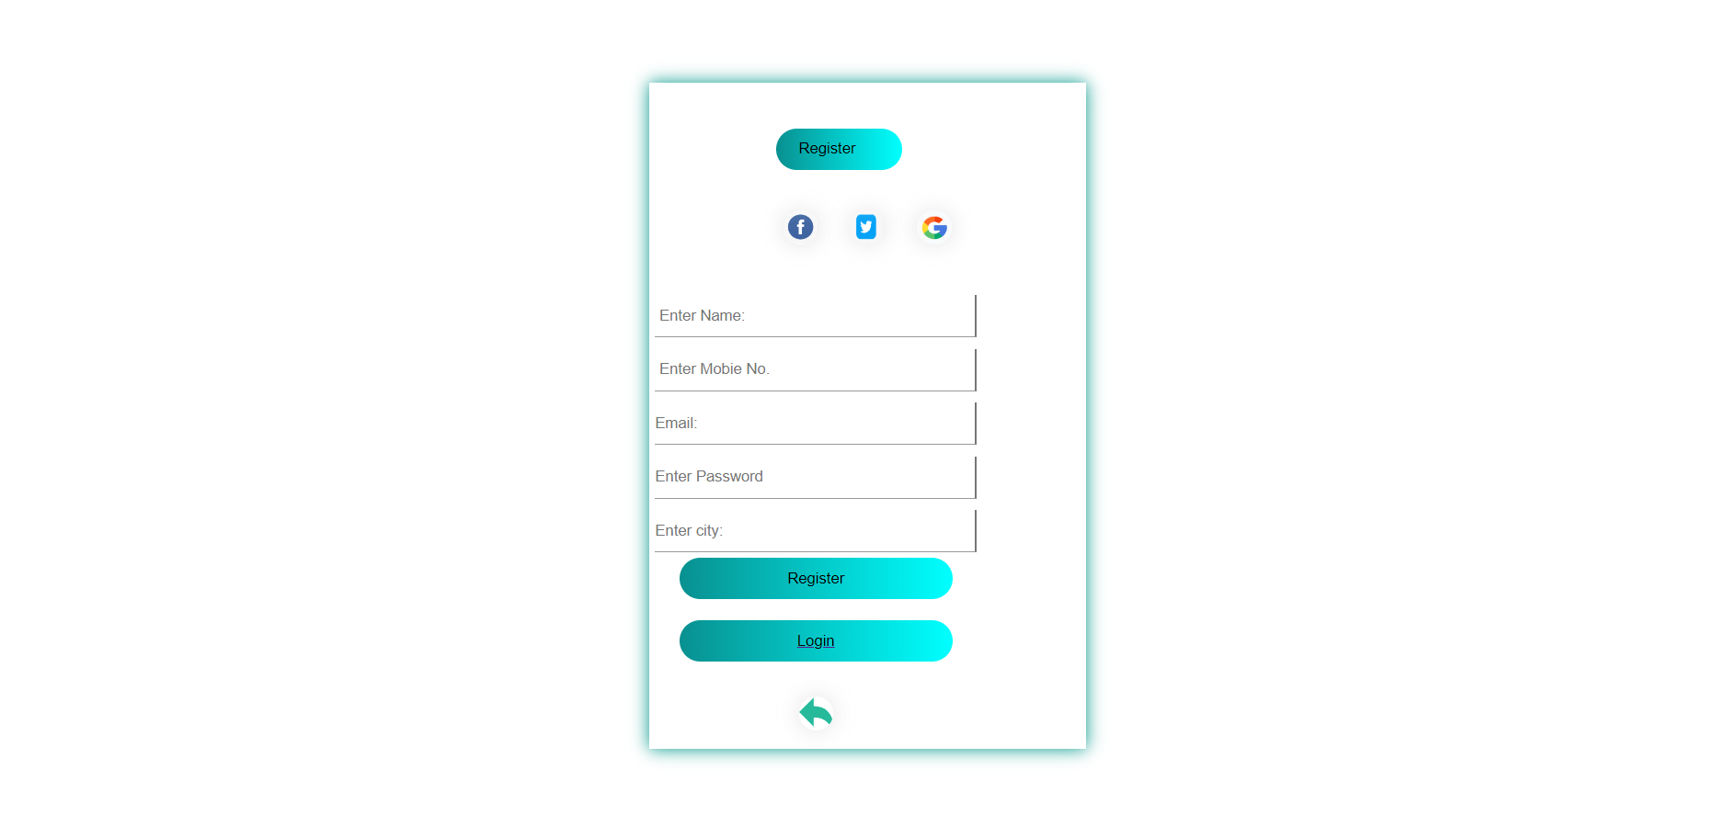



**Developed By: NANDANI SOLANKI**



**FAMILY STUDIO**

**Developed By: NANDANI SOLANKI**

**2)User Side Screenshot:**



**FAMILY STUDIO**

* **Index page:**

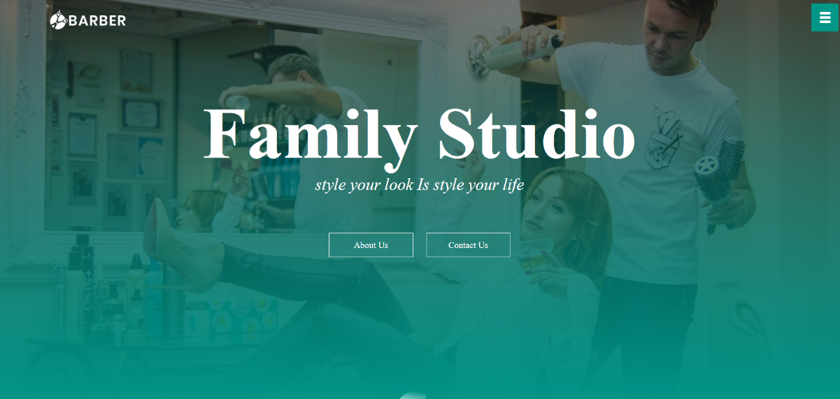

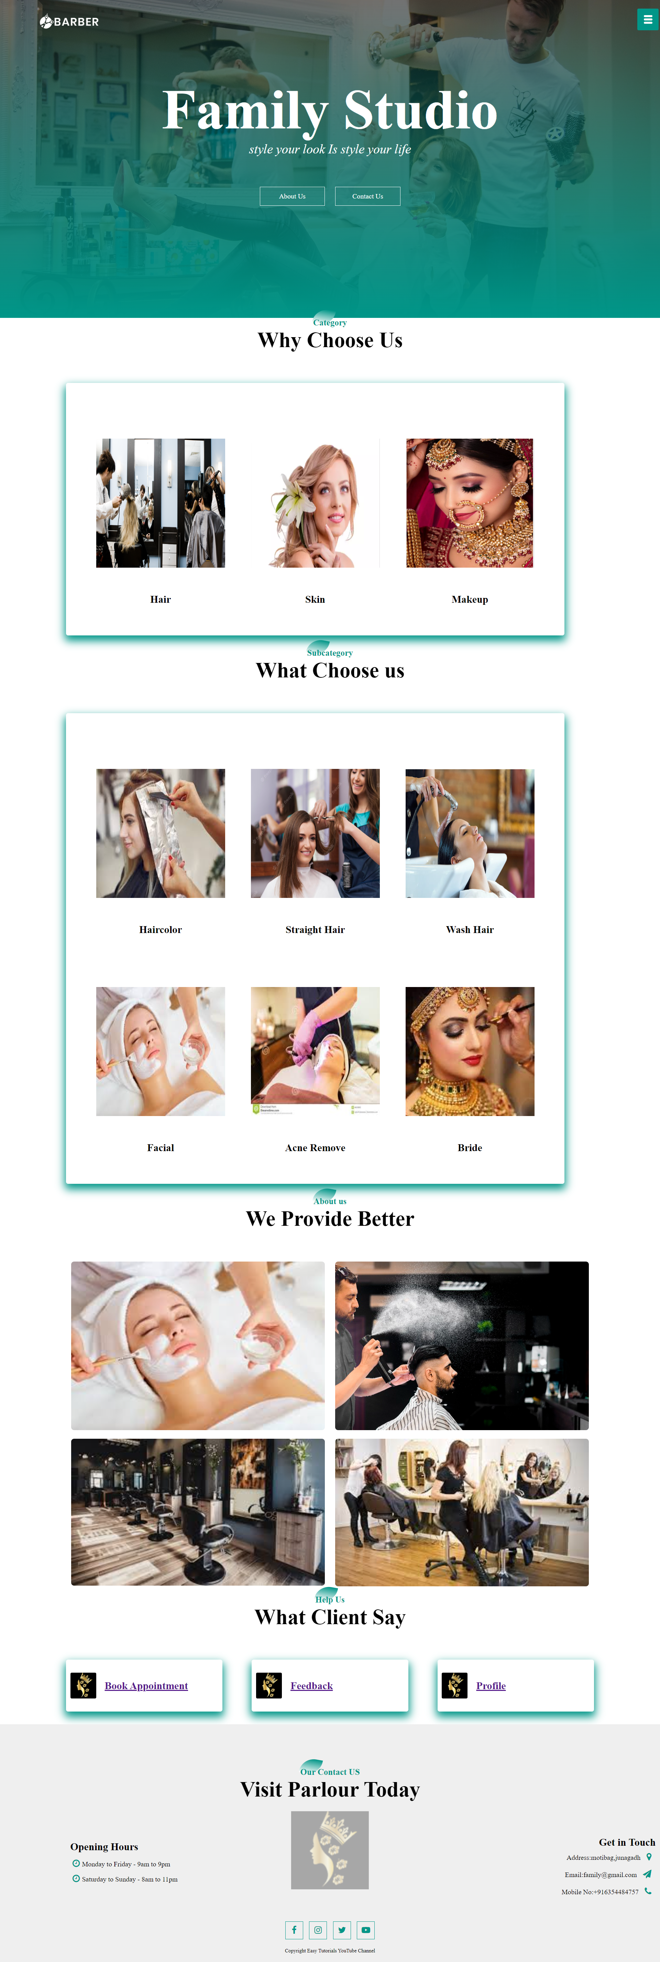

**Category page:**



**FAMILY STUDIO**

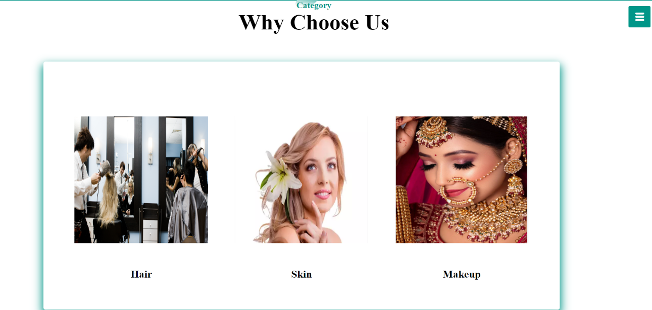

* **Subcategory page:**

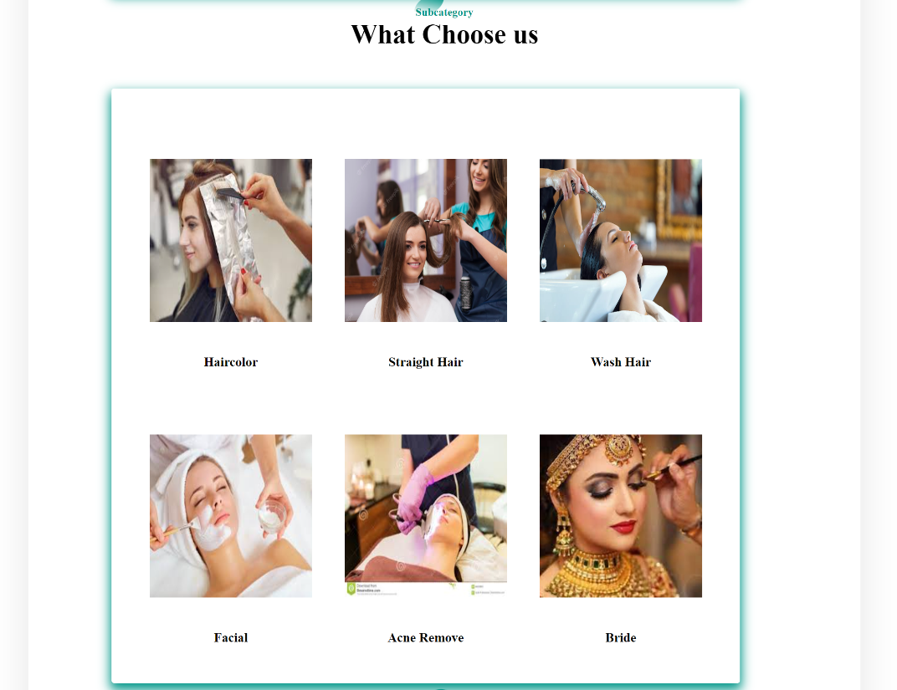

* **About US:**





**FAMILY STUDIO**

* 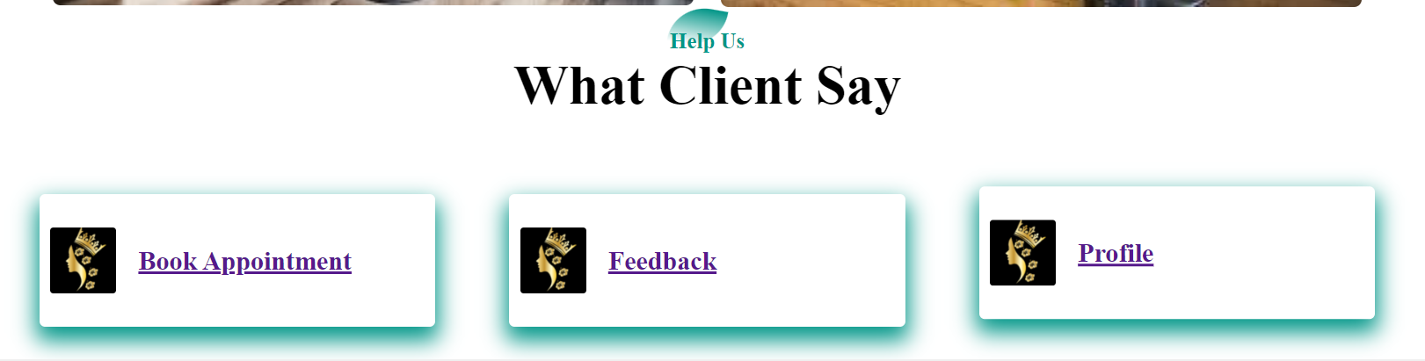 **BookAppointment , Feedback & Profile:**



**FAMILY STUDIO**

* **Appointment:**

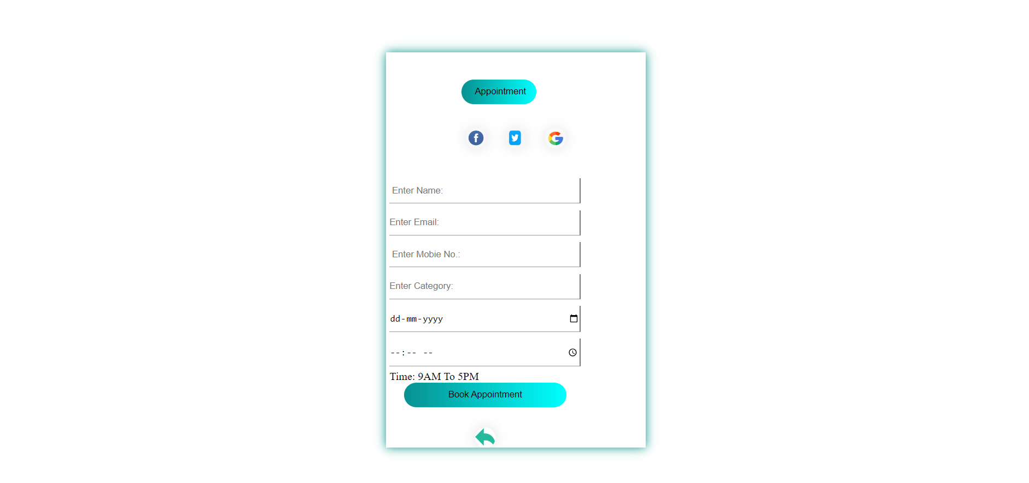

* **Feedback:**





**FAMILY STUDIO**

* **Profile:**

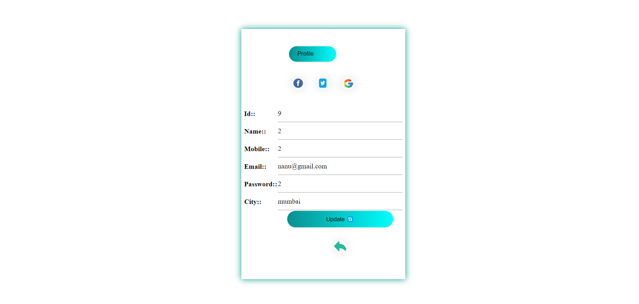

* **Faq:**

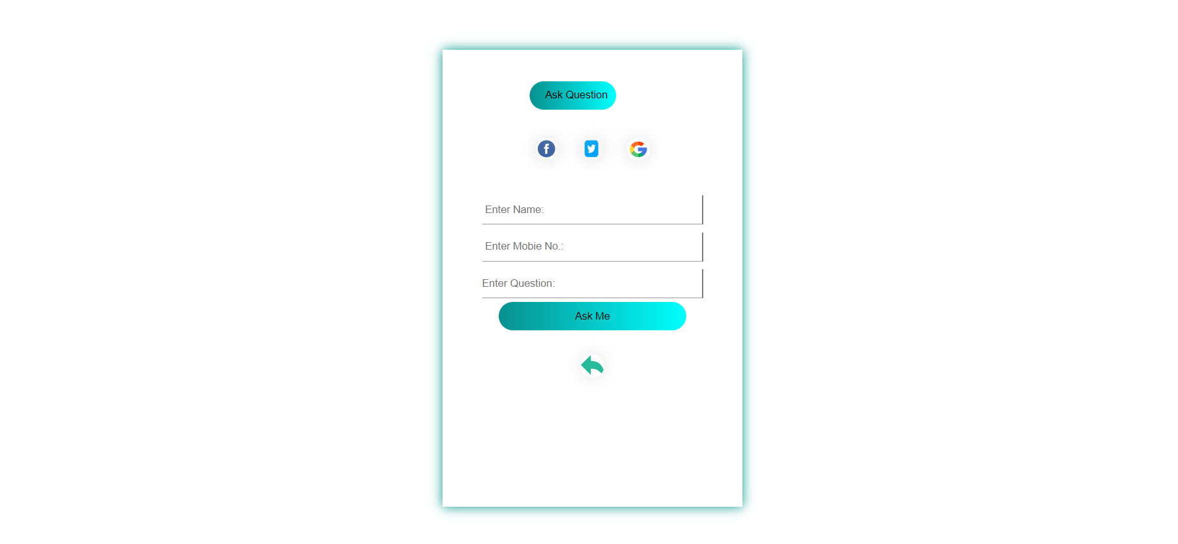

* **Contact us(parlour):**



**FAMILY STUDIO**

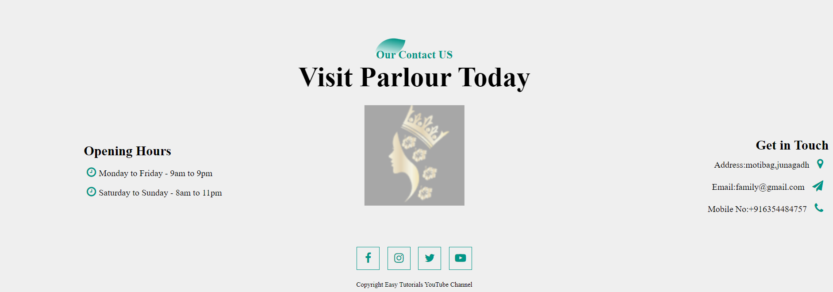

* **Contact us(user):**





**FAMILY STUDIO**

**3) Admin Side Screenshots: -**

* **Index page:**

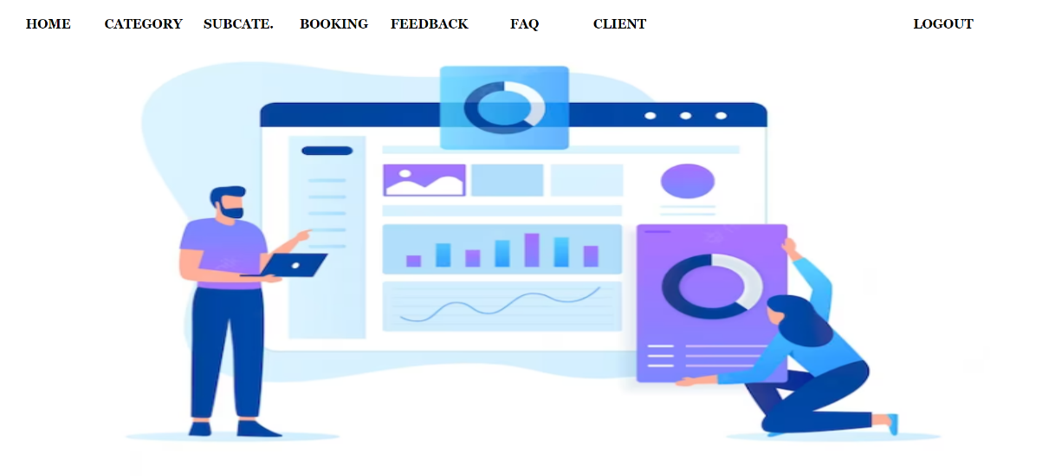

* **Category page:**

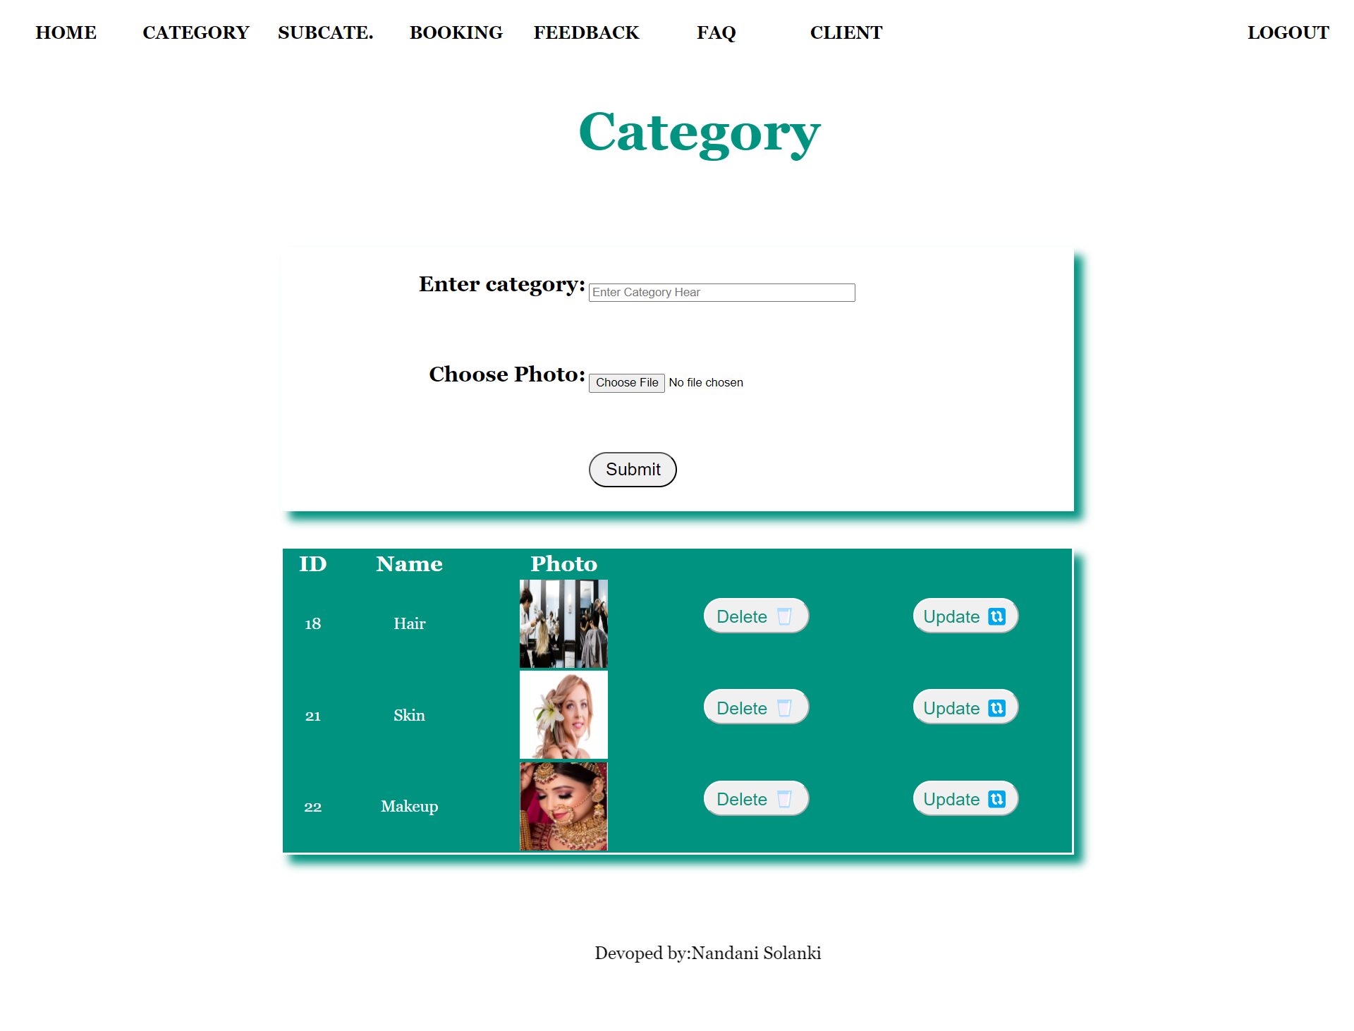

* **SubCategory page:**

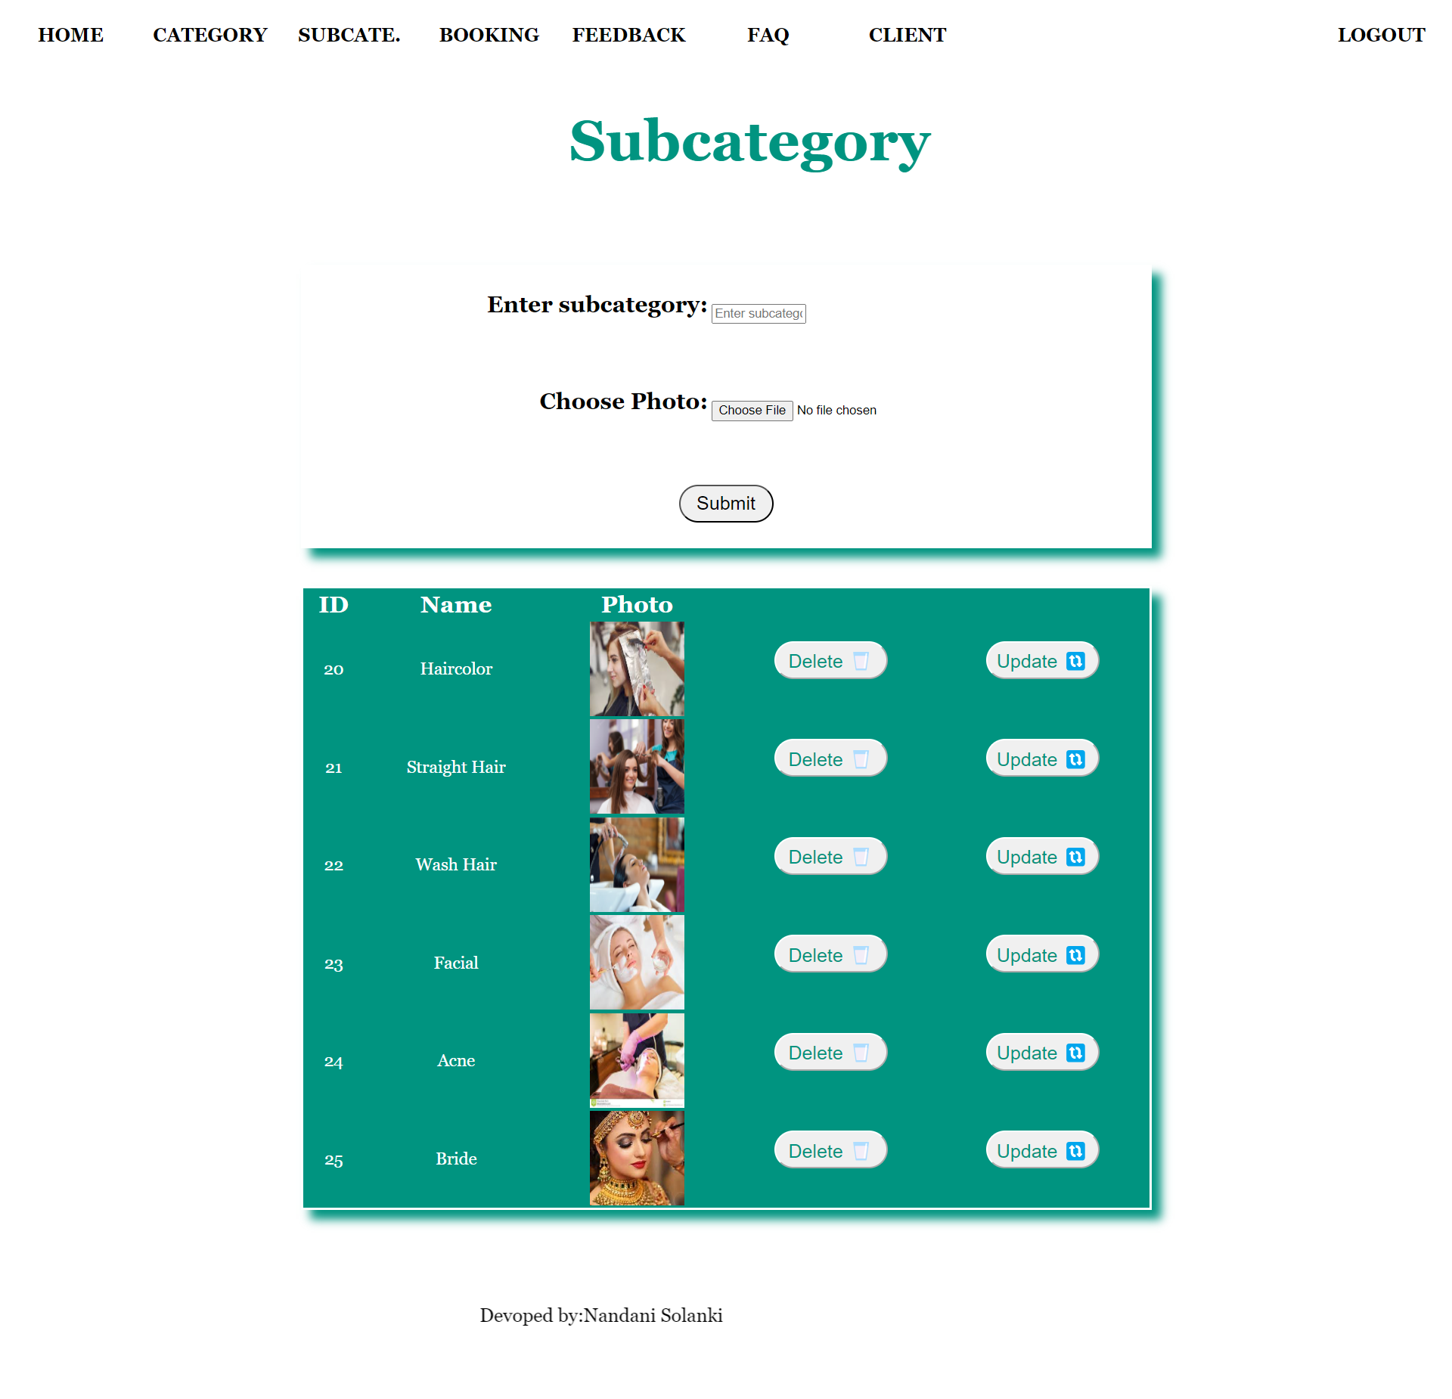

* **Booking:**

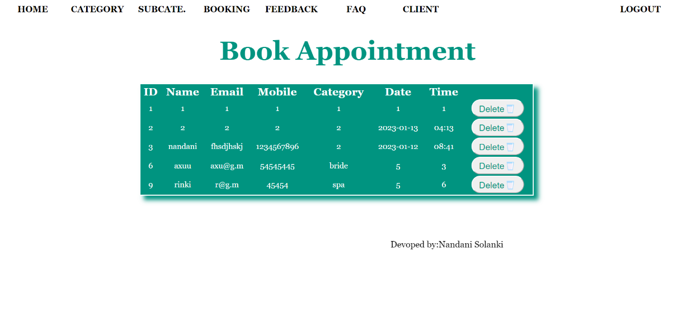



**FAMILY STUDIO**

* **Feedback:**

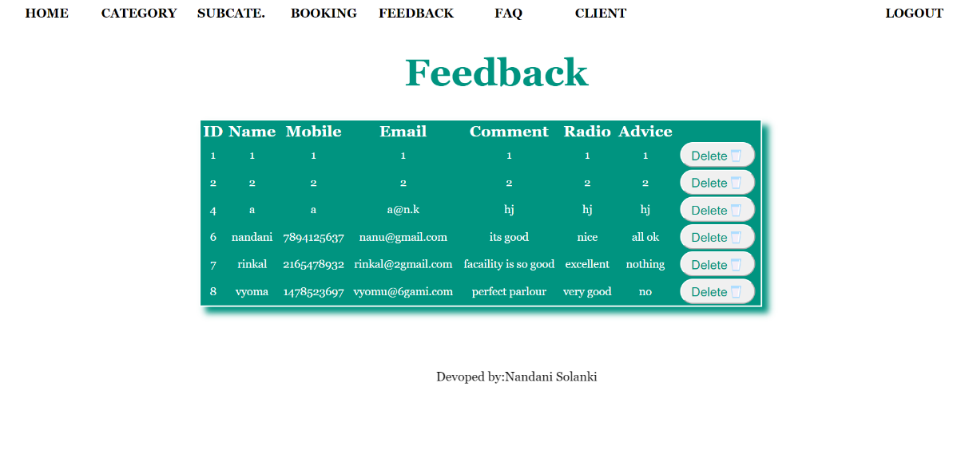

* 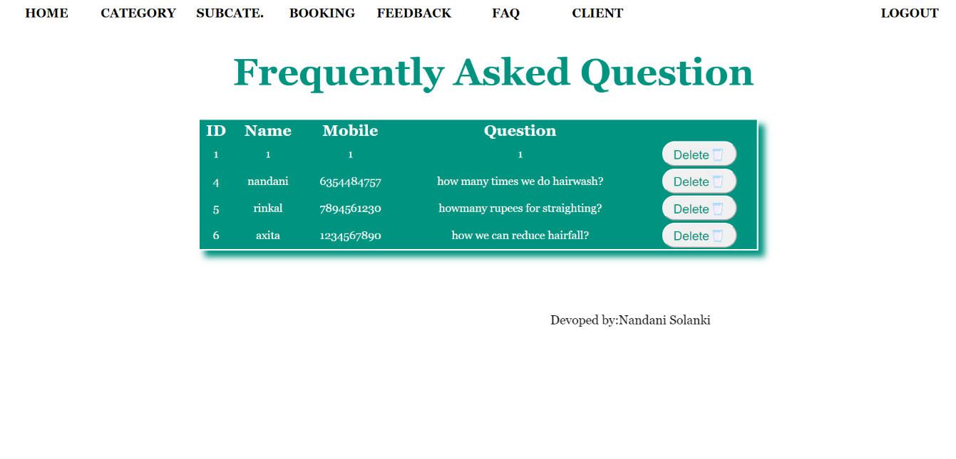**FAQ:**



**FAMILY STUDIO**



**FAMILY STUDIO**

* **Client:**

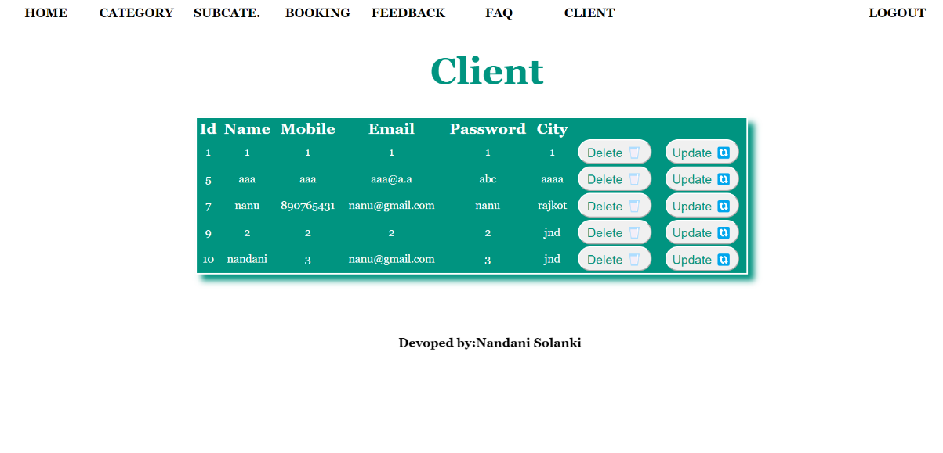



**FAMILY STUDIO**

**Chapter-5**

**Coding Screenshots**

**1) Visiters Side Screenshots: -**

* **Registration :**

<?php

include("dbconfig.php");

if(isset($_POST['submit']))

{

$name = $_POST['name'];

$mobile = $_POST['mobile'];

$email = $_POST['email'];

$pass = $_POST['pass'];

$city = $_POST['city'];

$q=mysqli_query($cn,"select * from registration where mobile='$mobile'");

$r=mysqli_num_rows($q);

if($r==0)

{

$q=mysqli_query($cn,"INSERT INTO `registration` (`id`, `name`, `mobile`, `email`, `password`, `city`, `type`) VALUES (NULL, '$name', '$mobile', '$email', '$pass', '$city', 'user');");

echo"<script>('Record Insert Sucessfully')</script>";

}

else

{

echo"<script>alert('User Already Registered')</script>";

//echo"<script>window.location='registration.php'</script>";

}

}

//echo"<script>window.location='index.php'</script>";

?>



**FAMILY STUDIO**

* **Login :**

<?php

session_start();

$mobile = $_POST['mobile'];

$pass = $_POST['pass'];

include('dbconfig.php');

$q = mysqli_query($cn,"select * from registration where mobile='$mobile' and password='$pass'");

$r=mysqli_fetch_row($q);

if($r[2]==$mobile && $r[4]==$pass && $r[6] =='user')

{

$_SESSION['username'] = $_POST['mobile'];

echo "<script>window.location='user/index.php'</script>";

}

else if($r[2]==$mobile && $r[4]==$pass && $r[6] =='admin')

{

$_SESSION['adminname'] = $_POST['mobile'];

echo "<script>window.location='admin/index.php'</script>";

}

else

{

echo "<script>alert('Enter Correct Username and Password');</script>";

echo "<script>window.location='login.php'</script>";

}

?>



**FAMILY STUDIO**

* **Feedback:**

<?php

include("dbconfig.php");

if(isset($_POST['submit']))

{

$name = $_POST['name'];

$mobile = $_POST['mobile'];

$email = $_POST['email'];

$comment = $_POST['comment'];

$feedback = $_POST['feedback'];

$advice = $_POST['advice'];

$q=mysqli_query($cn,"select * from feedback where id='$mobile'");

$r=mysqli_num_rows($q);

if($r==0)

{

$q=mysqli_query($cn,"INSERT INTO `feedback` (`id`, `name`, `mobile`, `email`, `comment`, `redio`, `advice`) VALUES (NULL, '$name', '$mobile', '$email', '$comment', '$feedback', '$advice');");

}

else

{

echo"<script>window.location='feedback.php'</script>";

}

}

echo"<script>window.location='index.php'</script>";

?>



**FAMILY STUDIO**

* **Contactus:**

<?php

include("dbconfig.php");

if(isset($_POST['submit']))

{

$name = $_POST['name'];

$mobile = $_POST['mobile'];

$email = $_POST['email'];

$city = $_POST['city'];

$q=mysqli_query($cn,"select * from contactus where id='$mobile'");

$r=mysqli_num_rows($q);

if($r==0)

{

$q=mysqli_query($cn,"INSERT INTO `contactus` (`id`, `name`, `mobile`, `email`, `city`) VALUES (NULL, '$name', '$mobile', '$email', '$city');");

}

else

{

echo"<script>window.location='contact.php'</script>";

}

}

echo"<script>window.location='index.php'</script>";

?>



**FAMILY STUDIO**

* **Faq:**

<?php

include('dbconfig.php');

$mobile = $_POST['mobile'];

$pass = $_POST['pass'];

$q = mysqli_query($cn,"select * from registration where mobile='$mobile'");

$r=mysqli_fetch_array($q);

if($r[2]==$mobile )

{

echo "<script>alert('password is $r[4]')</script>";

echo "<script>window.location='login.php'</script>";

}

else

{

echo "<script>alert('Enter Correct Password');</script>";

echo "<script>window.location='forget.php'</script>";

}

?>

**2) Users Side Screenshots: -**



**FAMILY STUDIO**

* **Profile:**

<?php

include("dbconfig.php");

$id = $_POST['id'];

if(isset($_POST['submit']))

{

$name = $_POST['name'];

$mobile = $_POST['mobile'];

$email = $_POST['email'];

$pass = $_POST['pass'];

$city = $_POST['city'];

// $photo = $_FILES['photo']['name'];

// move_uploaded_file($_FILES['photo']['tmp_name'],"../upload/".$_FILES['photo']['name']);

$q = mysqli_query($cn,"UPDATE registration SET name = '$name', mobile = '$mobile', email = '$email', password = '$pass', city = '$city' WHERE id = '$id'");

echo "<script>alert('Record Update Successfull')</script>";

echo "<script>document.location='profile.php'</script>";

}

else

{

echo "<script>alert('Invalid Operation')</script>";

echo "<script>document.location='index.php'</script>";

}

?>

* **Feedback:**



**FAMILY STUDIO**

<?php

include("dbconfig.php");

if(isset($_POST['submit']))

{

$name = $_POST['name'];

$mobile = $_POST['mobile'];

$email = $_POST['email'];

$comment = $_POST['comment'];

$feedback = $_POST['feedback'];

$advice = $_POST['advice'];

$q=mysqli_query($cn,"select * from feedback where id='$mobile'");

$r=mysqli_num_rows($q);

if($r==0)

{

$q=mysqli_query($cn,"INSERT INTO `feedback` (`id`, `name`, `mobile`, `email`, `comment`, `redio`, `advice`) VALUES (NULL, '$name', '$mobile', '$email', '$comment', '$feedback', '$advice');");

}

else

{

echo"<script>window.location='feedback.php'</script>";

}

}

echo"<script>window.location='index.php'</script>";

?>



**FAMILY STUDIO**

* **Faq:**

<?php

include("dbconfig.php");

if(isset($_POST['submit']))

{

$name = $_POST['name'];

$mobile = $_POST['mobile'];

$question = $_POST['question'];

$q=mysqli_query($cn,"select * from faq where id='$mobile'");

$r=mysqli_num_rows($q);

if($r==0)

{

$q=mysqli_query($cn,"INSERT INTO `faq` (`id`, `name`, `mobile`, `question`) VALUES (NULL, '$name', '$mobile', '$question');");

}

else

{

echo"<script>alert('User Already Registered')</script>";

echo"<script>window.location='faq.php'</script>";

}

}

echo"<script>window.location='index.php'</script>";

?>



**FAMILY STUDIO**

* **contactus:**

<?php

include("dbconfig.php");

if(isset($_POST['submit']))

{

$name = $_POST['name'];

$mobile = $_POST['mobile'];

$email = $_POST['email'];

$city = $_POST['city'];

$q=mysqli_query($cn,"select * from contactus where id='$mobile'");

$r=mysqli_num_rows($q);

if($r==0)

{

$q=mysqli_query($cn,"INSERT INTO `contactus` (`id`, `name`, `mobile`, `email`, `city`) VALUES (NULL, '$name', '$mobile', '$email', '$city');");

}

else

{

echo"<script>window.location='contact.php'</script>";

}

}

echo"<script>window.location='index.php'</script>";

?>

* **appointment:**



**FAMILY STUDIO**

<?php

include("dbconfig.php");

if(isset($_POST['submit']))

{

$name = $_POST['name'];

$email = $_POST['email'];

$mobile = $_POST['mobile'];

$category = $_POST['category'];

$date = $_POST['date'];

$time = $_POST['time'];

$q=mysqli_query($cn,"select * from bookapp where id='$mobile'");

$r=mysqli_num_rows($q);

if($r==0)

{

$q=mysqli_query($cn,"INSERT INTO `bookapp` (`id`, `name`, `email`, `mobile`, `category`, `date`, `time`) VALUES ('', '$name', '$email', '$mobile', '$category', '$date', '$time');");

}

else

{

echo"<script>alert('User Already Registered')</script>";

echo"<script>window.location='appointment.php'</script>";

}

}

echo"<script>window.location='index.php'</script>";

?>

* **logout:**



**FAMILY STUDIO**

<?php

session_start();

unset($_SESSION['username']);

session_destroy();

header("location:../login.php");

?>

**3) Admin Side Screenshots: -**



**FAMILY STUDIO**

* **subcategory:**

<?php

include("dbconfig.php");

if(isset($_POST['submit']))

{

$subcategory = $_POST['subcategory'];

$photo = $_FILES['photo']['name'];

move_uploaded_file($_FILES['photo']['tmp_name'],"../upload/".$_FILES['photo']['name']);

$q=mysqli_query($cn,"SELECT * FROM subcategory where name ='".$subcategory."'");

$r=mysqli_num_rows($q);

if($r==0)

{

$q=mysqli_query($cn,"INSERT INTO subcategory (name, photo) VALUES ('$subcategory','$photo')");

}

else

{

echo"<script>alert('subcategory Already Registered')</script>";

echo"<script>window.location='subcategory.php'</script>";

}

}

echo"<script>window.location='subcategory.php'</script>";

?>

* **category:**



**FAMILY STUDIO**

<?php

include("dbconfig.php");

if(isset($_POST['submit'])){

$category = $_POST['category'];

$photo = $_FILES['photo']['name'];

move_uploaded_file($_FILES['photo']['tmp_name'],"../upload/".$_FILES['photo']['name']);

$q=mysqli_query($cn,"SELECT * FROM category where name ='$category'");

$r=mysqli_num_rows($q);

if($r>0){

echo"<script>alert('Specialist Already Registered')</script>";

echo"<script>window.location='category.php'</script>";

}

else{

$q=mysqli_query($cn,"INSERT INTO category(name, photo)VALUES('$category', '$photo')");

}

}

echo"<script>window.location='category.php'</script>";

?>

* **client:**



**FAMILY STUDIO**

<?php

include("dbconfig.php");

include("header.php");

$id=$_POST['id'];

$name=$_POST['name'];

$mobile=$_POST['mobile'];

$email=$_POST['email'];

$password=$_POST['password'];

$city=$_POST['city'];

$q=mysqli_query($cn,"update registration set name='$name',mobile='$mobile',email='$email',password='$password',city='$city' where id='$id'");

?>

<script>

window.location="client.php";

</script>

**Chapter-6**

**Testing**



**FAMILY STUDIO**

**6.1 Techniques and strategies**

**6.2 Cost estimation model**

**6.3 Future scope and further enhancement of the project**

**6.4 Bibliography**

**6.5 Appendices**

**6.6 Glossary**

**6.1 TECHNIQUES AND STRATEGIES**



**FAMILY STUDIO**

Testing is a process to show the corrections of the program. Testing is needed to show completeness, to improve the quality of the software and to provide the maintenance aid. Some testing standards are therefore necessary reduce the testing costs and operation time.

Testing software extends throughout the coding phase and it represents the ultimate review of configurations, design and coding. Based on the way the software reacts to these testing.

We can decide whether the configuration that has been built is study or not. All components of an application are tested, as the failure to do so many results in a series of bugs after the software is put to use.

* **White Boxing:**

White Box (or glass box) testing is the process of giving input to the system and checking how the system processes input to generate output.



**FAMILY STUDIO**

It refers to the testing a system with full knowledge and access to all source code and other architecture documents. This testing enables to reveal bugs and vulnerabilities quickly in comparison with trial and error method. More complete testing coverage is ensured by exactly knowing what to test.

White box testing involves thorough testing of the application. It requires knowledge of code and the test cases chosen verifies if the system is implemented as expected. It typically includes checking with the data flow, exceptions, and errors, how they are handled, comparing if the code produces the expected results.

* **Black Box Testing:**

Black Box testing is the process of giving input to the system and checking the output of the system without bothering how the output is generated.

It refers to testing a system without knowledge of specification to the internal workings of the system, access to the source code, and knowledge of the architecture.

Essentially this approach mimics in a close approach, how an attacker typically follows approach to the application. However, the uncovering of issues or vulnerabilities could be further longer, because of lacking internal application knowledge.

Black box testing is done at an outer level of the system. Test cases merely check if the output is correct



**FAMILY STUDIO**

for the given input. User is not expected to the internal flow or design of the system.

* **Gray Box Testing:**

Grey Box testing is a combination of White Box and Glass Box Testing. In this, the tester has little knowledge about the internal working of the software.

So, he tests the output as well as process carried out to generate the output.

It refers to a testing system by knowing limited information about the internals of the system. The knowledge is always limited for detailed design documents and architecture diagrams. In concise, it is a good blend of black and white box testing, which leverages the strengths of each of the testing.

Grey box testing is a combination of both black box and white box testing. This is because it involves access to the system; however, at an outer level. A little knowledge of the system is expected in Grey box testing.



**FAMILY STUDIO**

* **Non-functional Testing:**

Non-functional testing is the testing of a software application or system for its non-functional Requirements: the way a system operates, rather than specific behaviours of that system. This is contrast to functional testing, which tests against functional requirements that describe the functions of a system and its components. The names of many non-functional tests are often used interchangeably because of the overlap in scope between various non-functional requirements. For example, software performance is a broad term that includes many specific requirements like reliability and scalability.



**FAMILY STUDIO**

* **Software Testing Strategies:**

Testing Involves:

1. Unit Testing
2. Integration Testing
3. Acceptance testing

**A. Unit Testing:**

The unit testing is purpose of unit testing is to ensure that each program is fully tested.

**B. Integration Testing:**

The integration testing is individual program units or programs are integrated and tested as a complete system to ensure that the software.

**C. Acceptance Testing:**

This testing involves planning and the execution of various types of test in order to demonstrate that the implemented software system satisfied the requirements. Finally, our project meets the requirements after going through all the levels of testing.

**6.2 COST ESTIMATION MODEL**



**FAMILY STUDIO**

 **Costing Objectives: -**

* **To ensure viability:**
* Feasibility study
* Resource planning
* Cost/benefit analysis
* **Provide input for pricing (including bidding negotiations etc.)**
* **To serve as a management tool:**
* Cost Control and Management
* Risk management
* Budget planning
* **Criteria for good project costing:**
* Accurate
* Realistic (good procurement and engineering practice)
* Consistent
* Transparent
* st-effective
* Goof Documentation.

Many looks upon project testing as a cost. While it is true that software testing does cost money, in many cases significant amounts of money, it is also an activity that an organization to avoid costly failures further on in the development process.

Most understand this relationship project testing is spending money to save money. What many do not also realize is that software testing also produces valuable assets for the organization. This article will discuss those assets of software testing.

* **Cost Estimation:**

Working time estimation is as given,

2 months + 20 days = 85 days

5 hr / day 460 hours

Now, the expenses & cost estimation are given below:

|  |  |
| --- | --- |
| Computer rent  + Light Bill Rs. 5 / unit | = 8,000 /- |
| Worth 400 units | = 2,000 /- |
| + Database design & creation | = 1,500 /- |
| + Coding& Validation | = 2500 /- |
| Amount | = 12,000 /- |

Total = 14,000 /-



**FAMILY STUDIO**

**SDLC MODEL**



**FAMILY STUDIO**

* **Waterfall Model:**

Waterfall approach was first SDLC Model to be used widely in Software Engineering to ensure success of the project. In "The Waterfall" approach, the whole process of software development is divided into separate phases. In Waterfall model, typically, the outcome of one phase acts as the input for the next phase sequentially. Following is a diagrammatic representation of different phases of waterfall model.

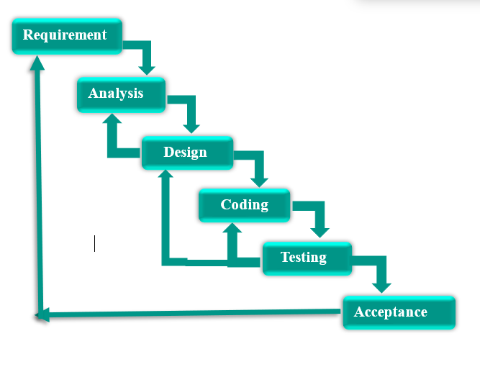



**FAMILY STUDIO**

## **Iterative Model:**

In Iterative model, iterative process starts with a simple implementation of a small set of the software requirements and iteratively enhances the evolving versions until the complete system is implemented and ready to be deployed. An iterative life cycle model does not attempt to start with a full specification of requirements. Instead, development begins by specifying and implementing just part of the software, which is then reviewed in order to identify further requirements. This process is then repeated, producing a new version of the software at the end of each iteration of the model.

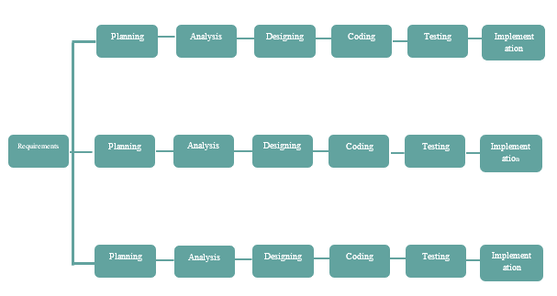

## **V- Model:**



**FAMILY STUDIO**

The V - model is SDLC model where execution of processes happens in a sequential manner in V-shape. It is also known as Verification and Validation model. V - Model is an extension of the waterfall model and is based on association of a testing phase for each corresponding development stage. This means that for every single phase in the development cycle there is a directly associated testing phase. This is a highly disciplined model and next phase starts only after completion of the previous phase.

## **V- Model Design:**

Under V-Model, the corresponding testing phase of the development phase is planned in parallel. So there are Verification phases on one side of the .V. and Validation phases on the other side. Coding phase joins the two sides of the V-Model. The below figure illustrates the different phases in V-Model of SDLC.

## 

* **V Model Diagram:**

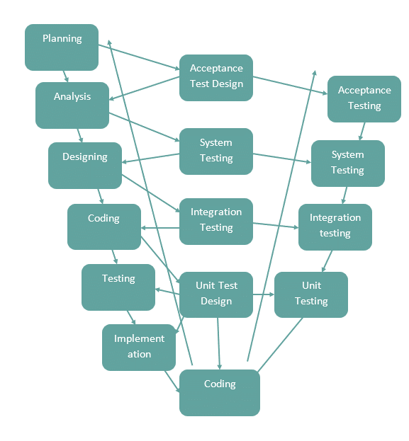



**FAMILY STUDIO**



**FAMILY STUDIO**

* **Spiral Model:**

The spiral model combines the idea of iterative development with the systematic, controlled aspects of the waterfall model. Spiral model is a combination of iterative development process model and sequential linear development model i.e. waterfall model with very high emphasis on risk analysis. It allows for incremental releases of the product, or incremental refinement through each iteration around the spiral.



**FAMILY STUDIO**



**FAMILY STUDIO**

* **Spiral Model Design:**

The spiral model has four phases. A software project repeatedly passes through these phases in iterations called Spirals.

* **Identification:**

This phase starts with gathering the business requirements in the baseline spiral. In the subsequent spirals as the product matures, identification of system requirements, subsystem requirements and unit requirements are all done in. This phase

This also includes understanding the system requirements by continuous communication between the customer and the system analyst. At the end of the spiral the product is deployed in the identified market.

* **Spiral Model Diagram:**



**FAMILY STUDIO**

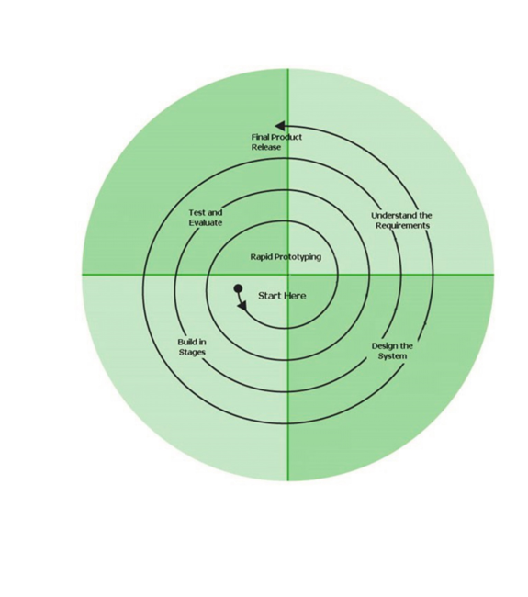

* **Prototype Model: -**

The basic idea here is that instead of freezing the requirements before a design or coding can proceed, a throwaway prototype is built to understand the requirements. This prototype is developed based on the currently known requirements. By using this prototype, the client can get an “actual feel” of the system, since the interactions with prototype can enable the client to better understand the requirements

of the desired system. Prototyping is an attractive idea for complicated and large systems for which there is no manual process or existing system to help determining the requirements. The prototype is usually not complete systems and many of the details are not built in the prototype. The goal is to provide a system with overall functionality.



**FAMILY STUDIO**

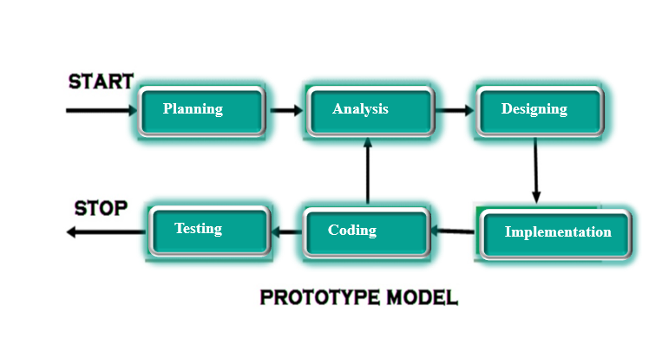



**FAMILY STUDIO**

**6.3 FUTURE ENHANCEMENT**

A good project is one which never stops developing according to the changing situationsand technologies there is a lot of scope of future enhancements.

* Product Add of Branded Companies
* Product Selling

**6.4 BIBLIOGRAPHY**

For the successful working of my project I have referred many sources for the code snippets, logic and tips and tricks from the various books as well as web sites. Most I searched for the required possessions on the google.com search engine.

**Web Link:**

* google.com
* Github.com
* w3school.com



**FAMILY STUDIO**

**6.5 APPENDICES**



**FAMILY STUDIO**

The Family studio fulfil all user requirement and give facility to users.

* The software takes care of all requirement and helps to the user.
* We have successfully designed, coded and implemented our project with a lot of Hard work.
* Finally, I would like to thank our project guide DR. NEHA K. SHAH helpful guidelines for our project. Also given suggestion when difficulties raised in our project.

**6.6 GLOSSARY**

|  |  |
| --- | --- |
| Full Form  **GANTT**  Generalized Activity Normalization  Time Table | |
| **D.F.D.** | Data Flow Diagram |
| **S.R.S.** | Software Requirement Specification |
| **P.E.R.T.** | Program Evaluation and Review Technique |
| **S.D.L.C** | Software Development Life Cycle |
| **E.R** | Entity Relationship |



**FAMILY STUDIO**

**THANK YOU**



**FAMILY STUDIO**